**HTML PROJECT ON**

**PHOTOGRAPHY**

**A PROJECT SUBMITTED ON PARTIAL FULFILMENT OF THE REQUIREMENTS OF THE AWARD OF DIPLOMA IN COMPUTER APPLICATION IN NERIM GROUP OF INSTITUTIONS UNDER DIBRUGARH UNIVERSITY AND APPROVED BY AICTE.**

**UNDER THE GUIDENCE OF**

**MR. SHEKHAR SINHA**

**DEPARTMENT OF COMPUTER SCIENCE**

**SUBMITTED BY**

**MD IFTIKAR HUSSAIN**

**BBA 6TH SEMESTER SEC-A**



**NERIM**

**NERIM GROUP OF INSTITUTION**

**PADMA NATH SARMAH BHAWAN,**

**JOYNAGAR, KHANAPARA, GUWAHATI-28**

**SESSION-2019-2022**

**REGISTRATION NO. 19949117**

**CERTIFICATE**

**THIS IS TO CERTIFY THAT THE PROJECT TITLED “WEBPAGE DESIGNING ON DEPRESSION”SUBMITTED BY MD IFTIKAR HUSSAIN**

**’ STUDENT OF BBA 6TH SEMESTER 2019-2022 IN NORTH EAST REGIONAL INSTITUTE OF MANAGEMNET, GUWAHTI UNDER THE GUIDENCE OF MR. SHEKHAR SINHA AND MANABENDRA NATH, ASST. PROF. FOR PARTIAL FULFILMENT OF THE REQUIREMENT OF THE BACHELOR OF BUSINESS ADMINISTRATION (BBA), EMBODIES THE BONAFIDE WORK DONE BY HIM UNDER MY SUPERVISION**

**MR. SHEKHAR SINHA**

**(PROJECT GUIDE)**

**ACKNOWLEDGEMENT**

**FIRST AND FOREMOST I WOULD LIKE TO WHOLE HEARTEDLY THANK AND EXPRESS MY SINCERE GRATITUDE AND REGARDS TO MY TEACHER MR. SHEKHAR SINGHA SIR AND FACULTY MEMBERS OF COMPUTER SCIENCE DEPARTMENT OF NERIM GROUP OF INSTITUIONS FOR THEIR CONSTANT GUIDANCE, SUPPORT AND ENCOURAGEMENT THROUGHOUT THE WORK AND IN COMPLETING THIS HTML PROJECT.**

**I WOULD ALSO LIKE TO THANK OUR RESPECTABLE CHAIRMAN DR. ZOII NATH SARMAH SIR, OUR RESPECTABLE DIRECTOR MA’AM DR.(PROF) SANGEETA TRIPATHI MADAM FOR GIVING ME THIS GREAT OPPORTUNITY AND LASTLY MY FAMILY FOR THEIR ENDLESS EFFORTS AND BROUGHT ME UP IN THIS LEVEL.**

**THANK YOU**

**CONTENT**

|  |  |  |
| --- | --- | --- |
| **S NO.** | **PARTICULRS** | **PAGE NO.** |
|  | **CERTIFICATE** |  |
|  | **ACKNOWLEDGEMENT** |  |
| **1** | **OVERVIEW** | **6** |
| **2** | **HOME PAGE** | **7-16** |
| **3** | **Symptoms and patterns** | **17-26** |
| **4** | **Medication** | **27-36** |
| **5** | **Self-help and Coping** | **37-46** |
| **6** | **How Is Depression Treated?** | **47-56** |
| **7** | **Risk Factors for Depression** | **57-66** |
| **8** | **Diagnosis and treatment** | **68-76** |
| **9** | **DOES DEPRESSION LOOK THE SAME IN EVERYONE?** | **77-86** |
|  | **WHO response** | **87-96** |
| **10** | **Refernces** | **97-105** |
|  | **CONCLUSION** |  |
|  | **BIBLIOGRAPHY** |  |

**OVERVIEW**

Depression is a common mental disorder. Globally, it is estimated that 5% of adults suffer from the disorder. It is characterized by persistent sadness and a lack of interest or pleasure in previously rewarding or enjoyable activities. It can also disturb sleep and appetite. Tiredness and poor concentration are common. Depression is a leading cause of disability around the world and contributes greatly to the global burden of disease. The effects of depression can be long-lasting or recurrent and can dramatically affect a person’s ability to function and live a rewarding life.

The causes of depression include complex interactions between social, psychological and biological factors. Life events such as childhood adversity, loss and unemployment contribute to and may catalyse the development of depression.

Psychological and pharmacological treatments exist for depression. However, in low- and middle-income countries, treatment and support services for depression are often absent or underdeveloped. It is estimated that more than 75% of people suffering from mental disorders in these countries do not receive treatment.

**HOME PAGE**

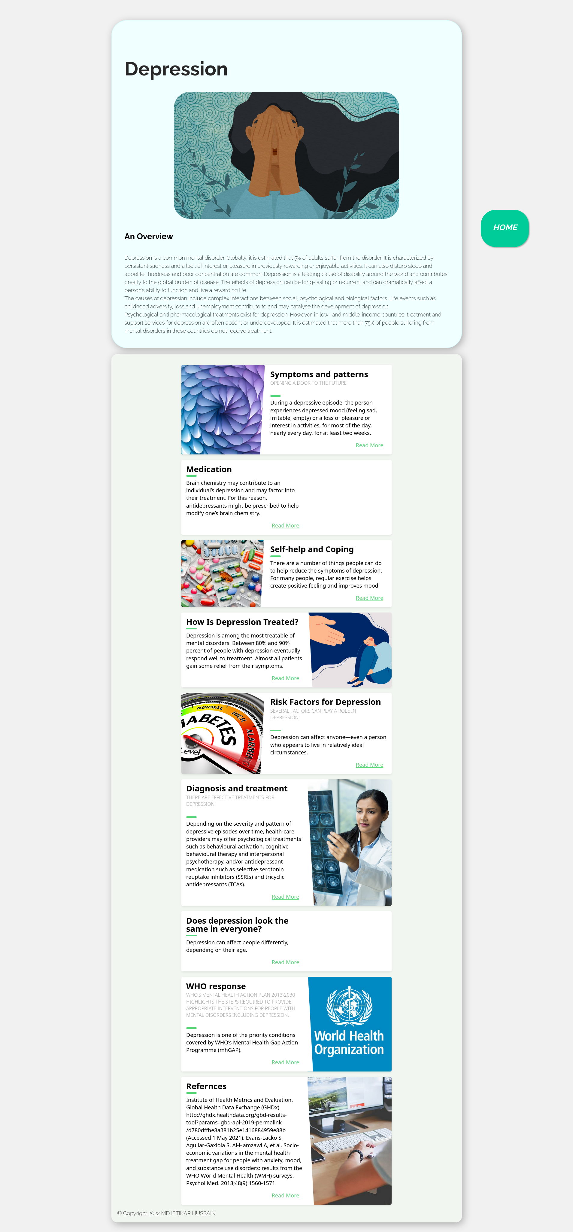

<!DOCTYPE html>

<html lang="en">

<head>

<meta charset="UTF-8">

<meta http-equiv="X-UA-Compatible" content="IE=edge">

<meta name="viewport" content="width=device-width, initial-scale=1.0">

<title>Depression</title>

<link rel="stylesheet" href="style.css">

</head>

<body>

<div id="title">

<div class="card">

<div class="topic">

<h1>Depression</h1>

</div>

<img src="assets/coping-with-depression-a-guide-to-good-treatment-1440x810.jpg" alt="">

<h2>An Overview</h2>

<div class="content">

<p>Depression is a common mental disorder. Globally, it is estimated that 5% of adults suffer from the

disorder. It is characterized by persistent sadness and a lack of interest or pleasure in previously

rewarding or enjoyable activities. It can also disturb sleep and appetite. Tiredness and poor

concentration are common. Depression is a leading cause of disability around the world and

contributes

greatly to the global burden of disease. The effects of depression can be long-lasting or recurrent

and

can dramatically affect a person’s ability to function and live a rewarding life. <br>

The causes of depression include complex interactions between social, psychological and biological

factors. Life events such as childhood adversity, loss and unemployment contribute to and may

catalyse

the development of depression. <br>

Psychological and pharmacological treatments exist for depression. However, in low- and

middle-income

countries, treatment and support services for depression are often absent or underdeveloped. It is

estimated that more than 75% of people suffering from mental disorders in these countries do not

receive

treatment.</p>

</div>

</div>

<div class="banner">

<div class="blog-card">

<div class="meta">

<div class="photo" style="background-image: url(assets/pattern.jpg)"></div>

<ul class="details">

<li class="author"><a href="#">IFTIKAR HUSSAIN</a></li>

<li class="date">Apr. 24, 2022</li>

<li class="tags">

<ul>

<li><a href="#">Learn</a></li>

<li><a href="#">more</a></li>

</ul>

</li>

</ul>

</div>

<div class="description">

<h1>Symptoms and patterns

</h1>

<h2>Opening a door to the future</h2>

<p> During a depressive episode, the person experiences depressed mood (feeling sad, irritable,

empty) or a

loss of pleasure or interest in activities, for most of the day, nearly every day, for at

least two weeks.

</p>

<p class="read-more">

<a href="./symtoms.html">Read More</a>

</p>

</div>

</div>

<div class="blog-card alt">

<div class="meta">

<div class="photo" style="background-image: url(assets/Medication.webp)">

</div>

<ul class="details">

<li class="author"><a href="#">IFTIKAR HUSSAIN</a></li>

<li class="date">July. 15, 2022</li>

<li class="tags">

<ul>

<li><a href="#">Learn</a></li>

<li><a href="#">more</a></li>

<li><a href="#"></a></li>

</ul>

</li>

</ul>

</div>

<div class="description">

<h1>Medication</h1>

<!-- <h2>depression</h2> -->

<p>Brain chemistry may contribute to an individual’s depression and may factor into their

treatment. For this

reason, antidepressants might be prescribed to help modify one’s brain chemistry.

</p>

<p class="read-more">

<a href="./medication.html">Read More</a>

</p>

</div>

</div>

<div class="blog-card">

<div class="meta">

<div class="photo" style="background-image: url(assets/help.jpg)">

</div>

<ul class="details">

<li class="author"><a href="#">IFTIKAR HUSSAIN</a></li>

<li class="date">Apr. 24, 2022</li>

<li class="tags">

<ul>

<li><a href="#">Learn</a></li>

<li><a href="#">more</a></li>

</ul>

</li>

</ul>

</div>

<div class="description">

<h1>Self-help and Coping

</h1>

<!-- <h2>Opening a door to the future</h2> -->

<p> There are a number of things people can do to help reduce the symptoms of depression. For

many people,

regular exercise helps create positive feeling and improves mood.

</p>

<p class="read-more">

<a href="./help.html">Read More</a>

</p>

</div>

</div>

<div class="blog-card alt">

<div class="meta">

<div class="photo" style="background-image: url(assets/treat.jpg)">

</div>

<ul class="details">

<li class="author"><a href="#">IFTIKAR HUSSAIN</a></li>

<li class="date">July. 15, 2022</li>

<li class="tags">

<ul>

<li><a href="#">Learn</a></li>

<li><a href="#">more</a></li>

<li><a href="#"></a></li>

</ul>

</li>

</ul>

</div>

<div class="description">

<h1>How Is Depression Treated?</h1>

<!-- <h2>depression</h2> -->

<p>Depression is among the most treatable of mental disorders. Between 80% and 90% percent of

people with

depression eventually respond well to treatment. Almost all patients gain some relief from

their symptoms.

</p>

<p class="read-more">

<a href="./treated.html">Read More</a>

</p>

</div>

</div>

<div class="blog-card">

<div class="meta">

<div class="photo" style="background-image: url(assets/risk.jpg)"></div>

<ul class="details">

<li class="author"><a href="#">IFTIKAR HUSSAIN</a></li>

<li class="date">Apr. 24, 2022</li>

<li class="tags">

<ul>

<li><a href="#">Learn</a></li>

<li><a href="#">more</a></li>

</ul>

</li>

</ul>

</div>

<div class="description">

<h1>Risk Factors for Depression

</h1>

<h2>Several factors can play a role in depression:</h2>

<!-- <h2>Opening a door to the future</h2> -->

<p> Depression can affect anyone—even a person who appears to live in relatively ideal

circumstances.

</p>

<p class="read-more">

<a href="./risk.html">Read More</a>

</p>

</div>

</div>

<div class="blog-card alt">

<div class="meta">

<div class="photo" style="background-image: url(assets/daignosin.jpg)">

</div>

<ul class="details">

<li class="author"><a href="#">IFTIKAR HUSSAIN</a></li>

<li class="date">July. 15, 2022</li>

<li class="tags">

<ul>

<li><a href="#">Learn</a></li>

<li><a href="#">more</a></li>

<li><a href="#"></a></li>

</ul>

</li>

</ul>

</div>

<div class="description">

<h1>Diagnosis and treatment</h1>

<h2>There are effective treatments for depression. </h2>

<p>Depending on the severity and pattern of depressive episodes over time, health-care providers

may offer

psychological treatments such as behavioural activation, cognitive behavioural therapy and

interpersonal

psychotherapy, and/or antidepressant medication such as selective serotonin reuptake

inhibitors (SSRIs) and

tricyclic antidepressants (TCAs). </p>

<p class="read-more">

<a href="./daignosis.html">Read More</a>

</p>

</div>

</div>

<div class="blog-card alt">

<div class="meta">

<div class="photo" style="background-image: url(assets/look.jpeg)">

</div>

<ul class="details">

<li class="author"><a href="#">IFTIKAR HUSSAIN</a></li>

<li class="date">July. 15, 2022</li>

<li class="tags">

<ul>

<li><a href="#">Learn</a></li>

<li><a href="#">more</a></li>

<li><a href="#"></a></li>

</ul>

</li>

</ul>

</div>

<div class="description">

<h1>Does depression look the same in everyone?</h1>

<!-- <h2>depression</h2> -->

<p>Depression can affect people differently, depending on their age.

</p>

<p class="read-more">

<a href="./look.html ">Read More</a>

</p>

</div>

</div>

<div class="blog-card alt">

<div class="meta">

<div class="photo" style="background-image: url(assets/who.jpg)">

</div>

<ul class="details">

<li class="author"><a href="#">IFTIKAR HUSSAIN</a></li>

<li class="date">July. 15, 2022</li>

<li class="tags">

<ul>

<li><a href="#">Learn</a></li>

<li><a href="#">more</a></li>

<li><a href="#"></a></li>

</ul>

</li>

</ul>

</div>

<div class="description">

<h1>WHO response</h1>

<h2>WHO’s Mental Health Action Plan 2013-2030 highlights the steps required to provide

appropriate

interventions for people with mental disorders including depression. </h2>

<p>Depression is one of the priority conditions covered by WHO’s Mental Health Gap Action

Programme (mhGAP).

</p>

<p class="read-more">

<a href="./who.html">Read More</a>

</p>

</div>

</div>

<div class="blog-card alt">

<div class="meta">

<div class="photo"

style="background-image: url(https://storage.googleapis.com/chydlx/codepen/blog-cards/image-2.jpg)">

</div>

<ul class="details">

<li class="author"><a href="#">Jane Doe</a></li>

<li class="date">July. 15, 2015</li>

<li class="tags">

<ul>

<li><a href="#">Learn</a></li>

<li><a href="#">more</a></li>

<li><a href="#"></a></li>

</ul>

</li>

</ul>

</div>

<div class="description">

<h1>Refernces</h1>

<!-- <h2>WHO’s Mental Health Action Plan 2013-2030 highlights the steps required to provide appropriate

interventions for people with mental disorders including depression. </h2> -->

<p>Institute of Health Metrics and Evaluation. Global Health Data Exchange (GHDx).

http://ghdx.healthdata.org/gbd-results-tool?params=gbd-api-2019-permalink/d780dffbe8a381b25e1416884959e88b

(Accessed 1 May 2021).

Evans-Lacko S, Aguilar-Gaxiola S, Al-Hamzawi A, et al. Socio-economic variations in the

mental health

treatment gap for people with anxiety, mood, and substance use disorders: results from the

WHO World Mental

Health (WMH) surveys. Psychol Med. 2018;48(9):1560-1571.

</p>

<p class="read-more">

<a href="./refer.html">Read More</a>

</p>

</div>

</div>

<footer>&copy Copyright 2022 MD IFTIKAR HUSSAIN </footer>

<a href="index.html" class="float">

<i class="fa fa-plus my-float">

<h2>HOME</h2>

</i>

</a>

</body>

</html>

**SYMPTOMS AND PATTERNS**

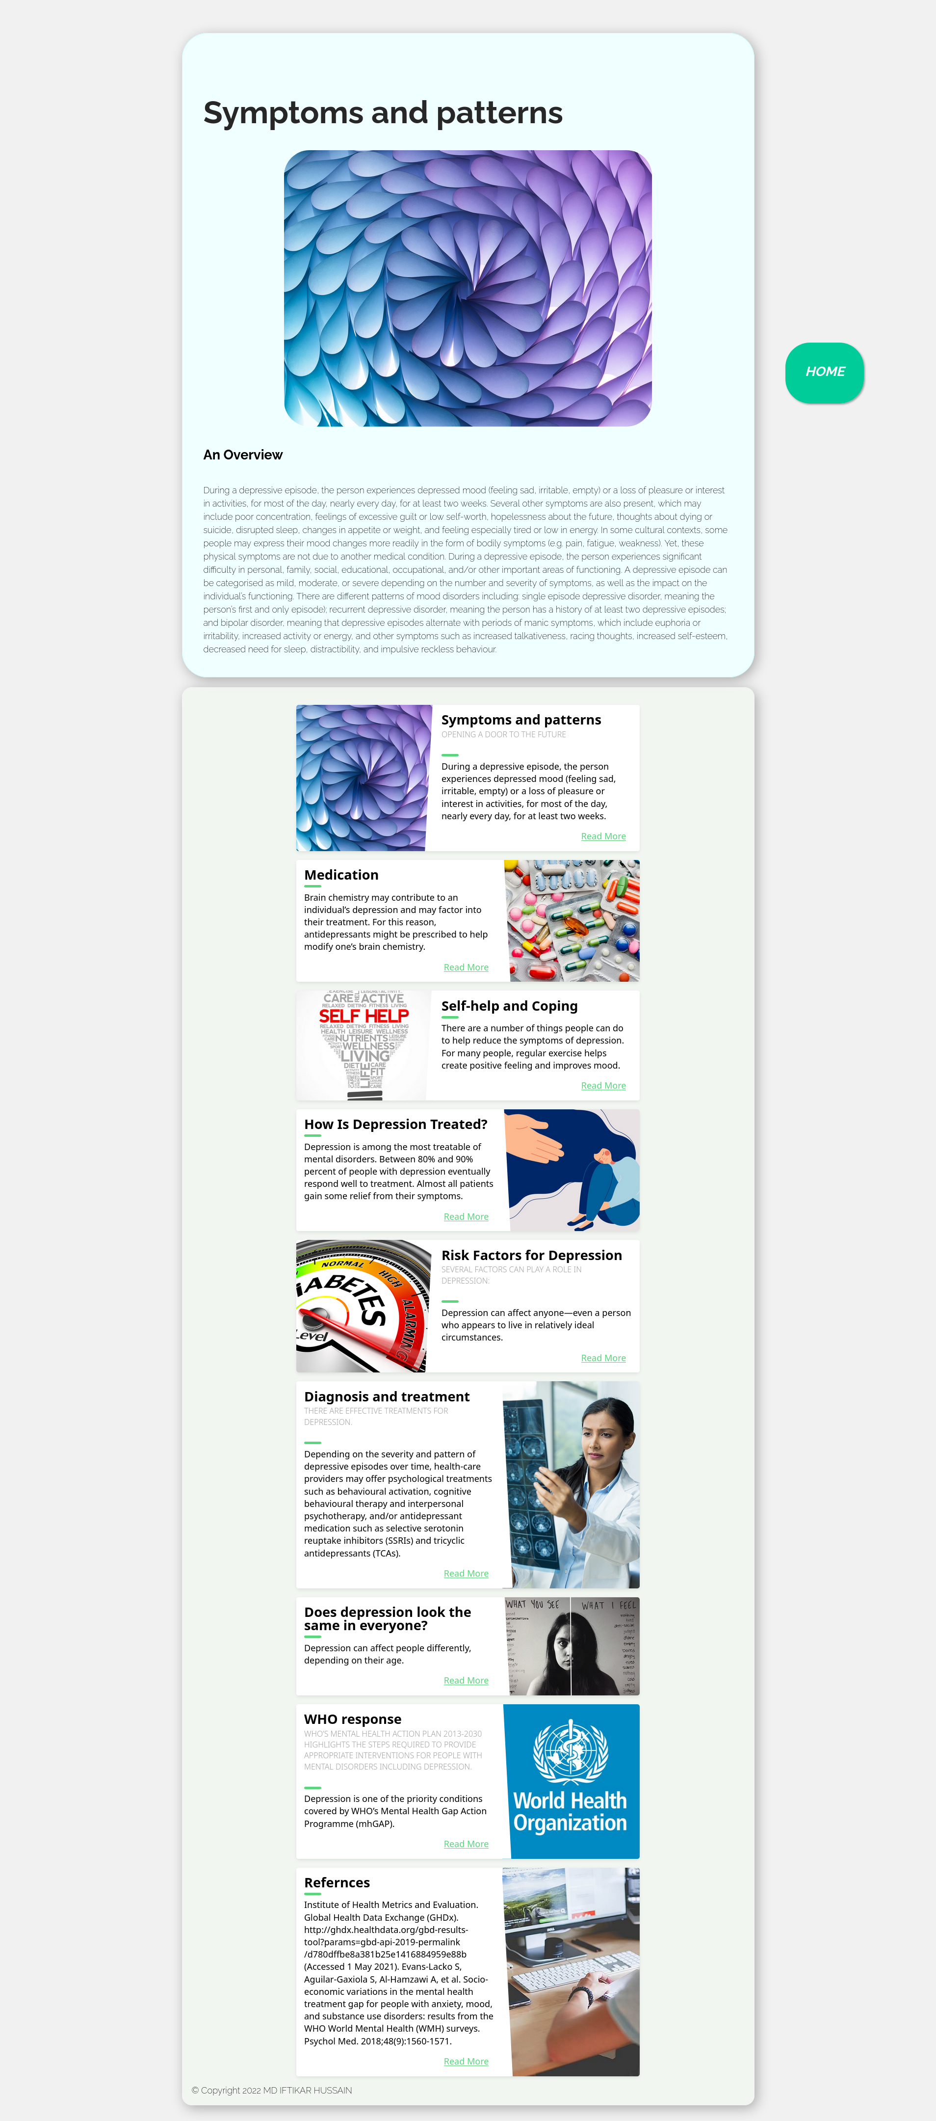

<!DOCTYPE html>

<html lang="en">

<head>

<meta charset="UTF-8">

<meta http-equiv="X-UA-Compatible" content="IE=edge">

<meta name="viewport" content="width=device-width, initial-scale=1.0">

<title>Symptoms and patterns</title>

<link rel="stylesheet" href="style.css">

</head>

<body>

<div id="title">

<div class="card">

<div class="topic">

<h1>Symptoms and patterns

</h1>

</div>

<img src="assets/pattern.jpg" alt="">

<h2>An Overview</h2>

<div class="content">

<p>During a depressive episode, the person experiences depressed mood (feeling sad, irritable, empty) or a loss

of pleasure or interest in activities, for most of the day, nearly every day, for at least two weeks. Several

other symptoms are also present, which may include poor concentration, feelings of excessive guilt or low

self-worth, hopelessness about the future, thoughts about dying or suicide, disrupted sleep, changes in

appetite or weight, and feeling especially tired or low in energy.

In some cultural contexts, some people may express their mood changes more readily in the form of bodily

symptoms (e.g. pain, fatigue, weakness). Yet, these physical symptoms are not due to another medical

condition.

During a depressive episode, the person experiences significant difficulty in personal, family, social,

educational, occupational, and/or other important areas of functioning.

A depressive episode can be categorised as mild, moderate, or severe depending on the number and severity of

symptoms, as well as the impact on the individual’s functioning.

There are different patterns of mood disorders including:

single episode depressive disorder, meaning the person’s first and only episode);

recurrent depressive disorder, meaning the person has a history of at least two depressive episodes; and

bipolar disorder, meaning that depressive episodes alternate with periods of manic symptoms, which include

euphoria or irritability, increased activity or energy, and other symptoms such as increased talkativeness,

racing thoughts, increased self-esteem, decreased need for sleep, distractibility, and impulsive reckless

behaviour.

</p>

</div>

</div>

<div class="banner">

<div class="blog-card">

<div class="meta">

<div class="photo" style="background-image: url(assets/pattern.jpg)"></div>

<ul class="details">

<li class="author"><a href="#">IFTIKAR HUSSAIN</a></li>

<li class="date">Apr. 24, 2022</li>

<li class="tags">

<ul>

<li><a href="#">Learn</a></li>

<li><a href="#">more</a></li>

</ul>

</li>

</ul>

</div>

<div class="description">

<h1>Symptoms and patterns

</h1>

<h2>Opening a door to the future</h2>

<p> During a depressive episode, the person experiences depressed mood (feeling sad, irritable,

empty) or a

loss of pleasure or interest in activities, for most of the day, nearly every day, for at

least two weeks.

</p>

<p class="read-more">

<a href="./symtoms.html">Read More</a>

</p>

</div>

</div>

<div class="blog-card alt">

<div class="meta">

<div class="photo" style="background-image: url(assets/Medication.webp)">

</div>

<ul class="details">

<li class="author"><a href="#">IFTIKAR HUSSAIN</a></li>

<li class="date">July. 15, 2022</li>

<li class="tags">

<ul>

<li><a href="#">Learn</a></li>

<li><a href="#">more</a></li>

<li><a href="#"></a></li>

</ul>

</li>

</ul>

</div>

<div class="description">

<h1>Medication</h1>

<!-- <h2>depression</h2> -->

<p>Brain chemistry may contribute to an individual’s depression and may factor into their

treatment. For this

reason, antidepressants might be prescribed to help modify one’s brain chemistry.

</p>

<p class="read-more">

<a href="./medication.html">Read More</a>

</p>

</div>

</div>

<div class="blog-card">

<div class="meta">

<div class="photo" style="background-image: url(assets/help.jpg)">

</div>

<ul class="details">

<li class="author"><a href="#">IFTIKAR HUSSAIN</a></li>

<li class="date">Apr. 24, 2022</li>

<li class="tags">

<ul>

<li><a href="#">Learn</a></li>

<li><a href="#">more</a></li>

</ul>

</li>

</ul>

</div>

<div class="description">

<h1>Self-help and Coping

</h1>

<!-- <h2>Opening a door to the future</h2> -->

<p> There are a number of things people can do to help reduce the symptoms of depression. For

many people,

regular exercise helps create positive feeling and improves mood.

</p>

<p class="read-more">

<a href="./help.html">Read More</a>

</p>

</div>

</div>

<div class="blog-card alt">

<div class="meta">

<div class="photo" style="background-image: url(assets/treat.jpg)">

</div>

<ul class="details">

<li class="author"><a href="#">IFTIKAR HUSSAIN</a></li>

<li class="date">July. 15, 2022</li>

<li class="tags">

<ul>

<li><a href="#">Learn</a></li>

<li><a href="#">more</a></li>

<li><a href="#"></a></li>

</ul>

</li>

</ul>

</div>

<div class="description">

<h1>How Is Depression Treated?</h1>

<!-- <h2>depression</h2> -->

<p>Depression is among the most treatable of mental disorders. Between 80% and 90% percent of

people with

depression eventually respond well to treatment. Almost all patients gain some relief from

their symptoms.

</p>

<p class="read-more">

<a href="./treated.html">Read More</a>

</p>

</div>

</div>

<div class="blog-card">

<div class="meta">

<div class="photo" style="background-image: url(assets/risk.jpg)"></div>

<ul class="details">

<li class="author"><a href="#">IFTIKAR HUSSAIN</a></li>

<li class="date">Apr. 24, 2022</li>

<li class="tags">

<ul>

<li><a href="#">Learn</a></li>

<li><a href="#">more</a></li>

</ul>

</li>

</ul>

</div>

<div class="description">

<h1>Risk Factors for Depression

</h1>

<h2>Several factors can play a role in depression:</h2>

<!-- <h2>Opening a door to the future</h2> -->

<p> Depression can affect anyone—even a person who appears to live in relatively ideal

circumstances.

</p>

<p class="read-more">

<a href="./risk.html">Read More</a>

</p>

</div>

</div>

<div class="blog-card alt">

<div class="meta">

<div class="photo" style="background-image: url(assets/daignosin.jpg)">

</div>

<ul class="details">

<li class="author"><a href="#">IFTIKAR HUSSAIN</a></li>

<li class="date">July. 15, 2022</li>

<li class="tags">

<ul>

<li><a href="#">Learn</a></li>

<li><a href="#">more</a></li>

<li><a href="#"></a></li>

</ul>

</li>

</ul>

</div>

<div class="description">

<h1>Diagnosis and treatment</h1>

<h2>There are effective treatments for depression. </h2>

<p>Depending on the severity and pattern of depressive episodes over time, health-care providers

may offer

psychological treatments such as behavioural activation, cognitive behavioural therapy and

interpersonal

psychotherapy, and/or antidepressant medication such as selective serotonin reuptake

inhibitors (SSRIs) and

tricyclic antidepressants (TCAs). </p>

<p class="read-more">

<a href="./daignosis.html">Read More</a>

</p>

</div>

</div>

<div class="blog-card alt">

<div class="meta">

<div class="photo" style="background-image: url(assets/look.jpeg)">

</div>

<ul class="details">

<li class="author"><a href="#">IFTIKAR HUSSAIN</a></li>

<li class="date">July. 15, 2022</li>

<li class="tags">

<ul>

<li><a href="#">Learn</a></li>

<li><a href="#">more</a></li>

<li><a href="#"></a></li>

</ul>

</li>

</ul>

</div>

<div class="description">

<h1>Does depression look the same in everyone?</h1>

<!-- <h2>depression</h2> -->

<p>Depression can affect people differently, depending on their age.

</p>

<p class="read-more">

<a href="./look.html ">Read More</a>

</p>

</div>

</div>

<div class="blog-card alt">

<div class="meta">

<div class="photo" style="background-image: url(assets/who.jpg)">

</div>

<ul class="details">

<li class="author"><a href="#">IFTIKAR HUSSAIN</a></li>

<li class="date">July. 15, 2022</li>

<li class="tags">

<ul>

<li><a href="#">Learn</a></li>

<li><a href="#">more</a></li>

<li><a href="#"></a></li>

</ul>

</li>

</ul>

</div>

<div class="description">

<h1>WHO response</h1>

<h2>WHO’s Mental Health Action Plan 2013-2030 highlights the steps required to provide

appropriate

interventions for people with mental disorders including depression. </h2>

<p>Depression is one of the priority conditions covered by WHO’s Mental Health Gap Action

Programme (mhGAP).

</p>

<p class="read-more">

<a href="./who.html">Read More</a>

</p>

</div>

</div>

<div class="blog-card alt">

<div class="meta">

<div class="photo"

style="background-image: url(https://storage.googleapis.com/chydlx/codepen/blog-cards/image-2.jpg)">

</div>

<ul class="details">

<li class="author"><a href="#">Jane Doe</a></li>

<li class="date">July. 15, 2015</li>

<li class="tags">

<ul>

<li><a href="#">Learn</a></li>

<li><a href="#">more</a></li>

<li><a href="#"></a></li>

</ul>

</li>

</ul>

</div>

<div class="description">

<h1>Refernces</h1>

<!-- <h2>WHO’s Mental Health Action Plan 2013-2030 highlights the steps required to provide appropriate

interventions for people with mental disorders including depression. </h2> -->

<p>Institute of Health Metrics and Evaluation. Global Health Data Exchange (GHDx).

http://ghdx.healthdata.org/gbd-results-tool?params=gbd-api-2019-permalink/d780dffbe8a381b25e1416884959e88b

(Accessed 1 May 2021).

Evans-Lacko S, Aguilar-Gaxiola S, Al-Hamzawi A, et al. Socio-economic variations in the

mental health

treatment gap for people with anxiety, mood, and substance use disorders: results from the

WHO World Mental

Health (WMH) surveys. Psychol Med. 2018;48(9):1560-1571.

</p>

<p class="read-more">

<a href="./refer.html">Read More</a>

</p>

</div>

</div>

<footer>&copy Copyright 2022 MD IFTIKAR HUSSAIN </footer>

<a href="index.html" class="float">

<i class="fa fa-plus my-float">

<h2>HOME</h2>

</i>

</a>

</body>

</html>

**MEDICATION**

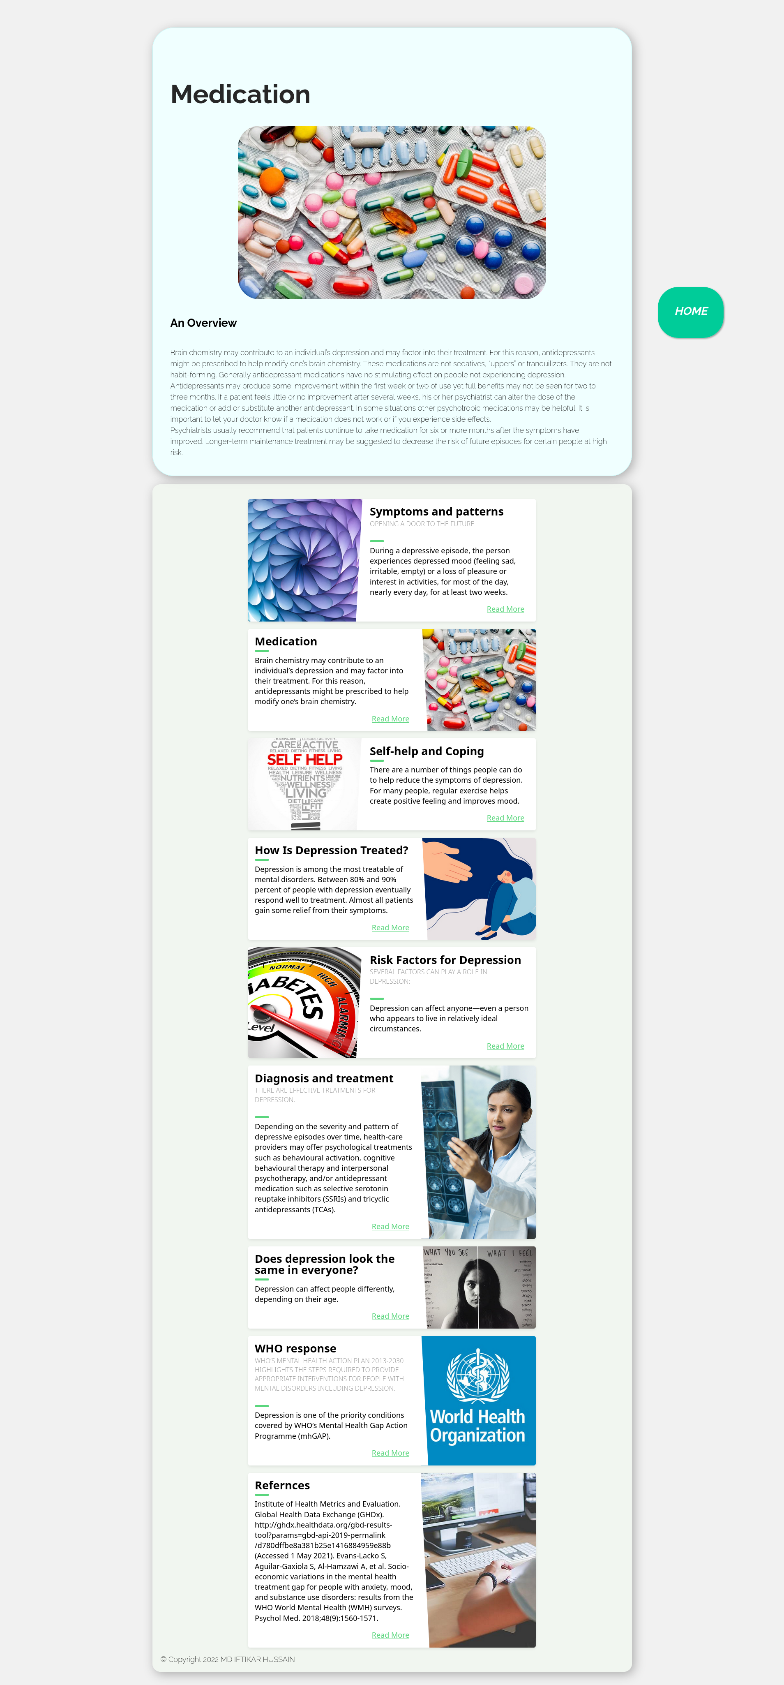

<!DOCTYPE html>

<html lang="en">

<head>

<meta charset="UTF-8">

<meta http-equiv="X-UA-Compatible" content="IE=edge">

<meta name="viewport" content="width=device-width, initial-scale=1.0">

<title>Medication</title>

<link rel="stylesheet" href="style.css">

</head>

<body>

<div id="title">

<div class="card">

<div class="topic">

<h1>Medication</h1>

</div>

<img src="assets/Medication.webp" alt="">

<h2>An Overview</h2>

<div class="content">

<p>Brain chemistry may contribute to an individual’s depression and may factor into their treatment. For

this reason, antidepressants might be prescribed to help modify one’s brain chemistry. These

medications are not sedatives, “uppers” or tranquilizers. They are not habit-forming. Generally

antidepressant medications have no stimulating effect on people not experiencing depression.

<br>

Antidepressants may produce some improvement within the first week or two of use yet full benefits

may not be seen for two to three months. If a patient feels little or no improvement after several

weeks, his or her psychiatrist can alter the dose of the medication or add or substitute another

antidepressant. In some situations other psychotropic medications may be helpful. It is important to

let your doctor know if a medication does not work or if you experience side effects.

<br>

Psychiatrists usually recommend that patients continue to take medication for six or more months

after the symptoms have improved. Longer-term maintenance treatment may be suggested to decrease the

risk of future episodes for certain people at high risk.

</p>

</div>

</div>

<div class="banner">

<div class="blog-card">

<div class="meta">

<div class="photo" style="background-image: url(assets/pattern.jpg)"></div>

<ul class="details">

<li class="author"><a href="#">IFTIKAR HUSSAIN</a></li>

<li class="date">Apr. 24, 2022</li>

<li class="tags">

<ul>

<li><a href="#">Learn</a></li>

<li><a href="#">more</a></li>

</ul>

</li>

</ul>

</div>

<div class="description">

<h1>Symptoms and patterns

</h1>

<h2>Opening a door to the future</h2>

<p> During a depressive episode, the person experiences depressed mood (feeling sad, irritable,

empty) or a

loss of pleasure or interest in activities, for most of the day, nearly every day, for at

least two weeks.

</p>

<p class="read-more">

<a href="./symtoms.html">Read More</a>

</p>

</div>

</div>

<div class="blog-card alt">

<div class="meta">

<div class="photo" style="background-image: url(assets/Medication.webp)">

</div>

<ul class="details">

<li class="author"><a href="#">IFTIKAR HUSSAIN</a></li>

<li class="date">July. 15, 2022</li>

<li class="tags">

<ul>

<li><a href="#">Learn</a></li>

<li><a href="#">more</a></li>

<li><a href="#"></a></li>

</ul>

</li>

</ul>

</div>

<div class="description">

<h1>Medication</h1>

<!-- <h2>depression</h2> -->

<p>Brain chemistry may contribute to an individual’s depression and may factor into their

treatment. For this

reason, antidepressants might be prescribed to help modify one’s brain chemistry.

</p>

<p class="read-more">

<a href="./medication.html">Read More</a>

</p>

</div>

</div>

<div class="blog-card">

<div class="meta">

<div class="photo" style="background-image: url(assets/help.jpg)">

</div>

<ul class="details">

<li class="author"><a href="#">IFTIKAR HUSSAIN</a></li>

<li class="date">Apr. 24, 2022</li>

<li class="tags">

<ul>

<li><a href="#">Learn</a></li>

<li><a href="#">more</a></li>

</ul>

</li>

</ul>

</div>

<div class="description">

<h1>Self-help and Coping

</h1>

<!-- <h2>Opening a door to the future</h2> -->

<p> There are a number of things people can do to help reduce the symptoms of depression. For

many people,

regular exercise helps create positive feeling and improves mood.

</p>

<p class="read-more">

<a href="./help.html">Read More</a>

</p>

</div>

</div>

<div class="blog-card alt">

<div class="meta">

<div class="photo" style="background-image: url(assets/treat.jpg)">

</div>

<ul class="details">

<li class="author"><a href="#">IFTIKAR HUSSAIN</a></li>

<li class="date">July. 15, 2022</li>

<li class="tags">

<ul>

<li><a href="#">Learn</a></li>

<li><a href="#">more</a></li>

<li><a href="#"></a></li>

</ul>

</li>

</ul>

</div>

<div class="description">

<h1>How Is Depression Treated?</h1>

<!-- <h2>depression</h2> -->

<p>Depression is among the most treatable of mental disorders. Between 80% and 90% percent of

people with

depression eventually respond well to treatment. Almost all patients gain some relief from

their symptoms.

</p>

<p class="read-more">

<a href="./treated.html">Read More</a>

</p>

</div>

</div>

<div class="blog-card">

<div class="meta">

<div class="photo" style="background-image: url(assets/risk.jpg)"></div>

<ul class="details">

<li class="author"><a href="#">IFTIKAR HUSSAIN</a></li>

<li class="date">Apr. 24, 2022</li>

<li class="tags">

<ul>

<li><a href="#">Learn</a></li>

<li><a href="#">more</a></li>

</ul>

</li>

</ul>

</div>

<div class="description">

<h1>Risk Factors for Depression

</h1>

<h2>Several factors can play a role in depression:</h2>

<!-- <h2>Opening a door to the future</h2> -->

<p> Depression can affect anyone—even a person who appears to live in relatively ideal

circumstances.

</p>

<p class="read-more">

<a href="./risk.html">Read More</a>

</p>

</div>

</div>

<div class="blog-card alt">

<div class="meta">

<div class="photo" style="background-image: url(assets/daignosin.jpg)">

</div>

<ul class="details">

<li class="author"><a href="#">IFTIKAR HUSSAIN</a></li>

<li class="date">July. 15, 2022</li>

<li class="tags">

<ul>

<li><a href="#">Learn</a></li>

<li><a href="#">more</a></li>

<li><a href="#"></a></li>

</ul>

</li>

</ul>

</div>

<div class="description">

<h1>Diagnosis and treatment</h1>

<h2>There are effective treatments for depression. </h2>

<p>Depending on the severity and pattern of depressive episodes over time, health-care providers

may offer

psychological treatments such as behavioural activation, cognitive behavioural therapy and

interpersonal

psychotherapy, and/or antidepressant medication such as selective serotonin reuptake

inhibitors (SSRIs) and

tricyclic antidepressants (TCAs). </p>

<p class="read-more">

<a href="./daignosis.html">Read More</a>

</p>

</div>

</div>

<div class="blog-card alt">

<div class="meta">

<div class="photo" style="background-image: url(assets/look.jpeg)">

</div>

<ul class="details">

<li class="author"><a href="#">IFTIKAR HUSSAIN</a></li>

<li class="date">July. 15, 2022</li>

<li class="tags">

<ul>

<li><a href="#">Learn</a></li>

<li><a href="#">more</a></li>

<li><a href="#"></a></li>

</ul>

</li>

</ul>

</div>

<div class="description">

<h1>Does depression look the same in everyone?</h1>

<!-- <h2>depression</h2> -->

<p>Depression can affect people differently, depending on their age.

</p>

<p class="read-more">

<a href="./look.html ">Read More</a>

</p>

</div>

</div>

<div class="blog-card alt">

<div class="meta">

<div class="photo" style="background-image: url(assets/who.jpg)">

</div>

<ul class="details">

<li class="author"><a href="#">IFTIKAR HUSSAIN</a></li>

<li class="date">July. 15, 2022</li>

<li class="tags">

<ul>

<li><a href="#">Learn</a></li>

<li><a href="#">more</a></li>

<li><a href="#"></a></li>

</ul>

</li>

</ul>

</div>

<div class="description">

<h1>WHO response</h1>

<h2>WHO’s Mental Health Action Plan 2013-2030 highlights the steps required to provide

appropriate

interventions for people with mental disorders including depression. </h2>

<p>Depression is one of the priority conditions covered by WHO’s Mental Health Gap Action

Programme (mhGAP).

</p>

<p class="read-more">

<a href="./who.html">Read More</a>

</p>

</div>

</div>

<div class="blog-card alt">

<div class="meta">

<div class="photo"

style="background-image: url(https://storage.googleapis.com/chydlx/codepen/blog-cards/image-2.jpg)">

</div>

<ul class="details">

<li class="author"><a href="#">Jane Doe</a></li>

<li class="date">July. 15, 2015</li>

<li class="tags">

<ul>

<li><a href="#">Learn</a></li>

<li><a href="#">more</a></li>

<li><a href="#"></a></li>

</ul>

</li>

</ul>

</div>

<div class="description">

<h1>Refernces</h1>

<!-- <h2>WHO’s Mental Health Action Plan 2013-2030 highlights the steps required to provide appropriate

interventions for people with mental disorders including depression. </h2> -->

<p>Institute of Health Metrics and Evaluation. Global Health Data Exchange (GHDx).

http://ghdx.healthdata.org/gbd-results-tool?params=gbd-api-2019-permalink/d780dffbe8a381b25e1416884959e88b

(Accessed 1 May 2021).

Evans-Lacko S, Aguilar-Gaxiola S, Al-Hamzawi A, et al. Socio-economic variations in the

mental health

treatment gap for people with anxiety, mood, and substance use disorders: results from the

WHO World Mental

Health (WMH) surveys. Psychol Med. 2018;48(9):1560-1571.

</p>

<p class="read-more">

<a href="./refer.html">Read More</a>

</p>

</div>

</div>

<footer>&copy Copyright 2022 MD IFTIKAR HUSSAIN </footer>

<a href="index.html" class="float">

<i class="fa fa-plus my-float">

<h2>HOME</h2>

</i>

</a>

</body>

</html>

**SELF-HELP AND COPING**

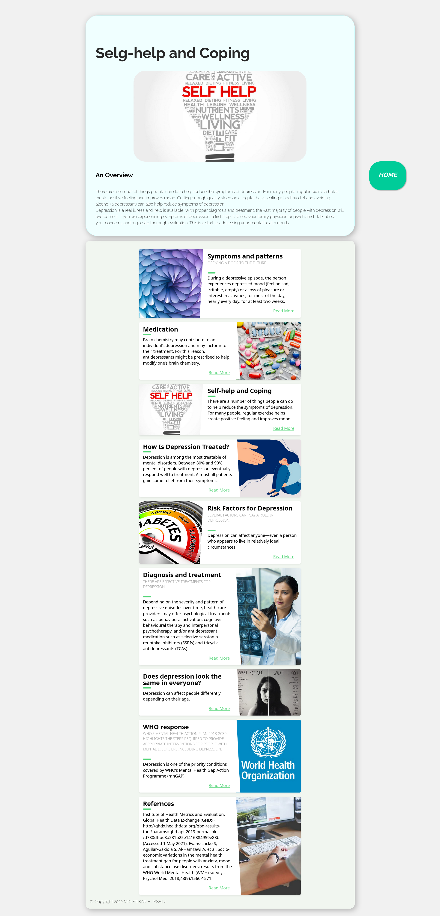

<!DOCTYPE html>

<html lang="en">

<head>

<meta charset="UTF-8">

<meta http-equiv="X-UA-Compatible" content="IE=edge">

<meta name="viewport" content="width=device-width, initial-scale=1.0">

<title>Depression</title>

<link rel="stylesheet" href="style.css">

</head>

<body>

<div id="title">

<div class="card">

<div class="topic">

<h1>Selg-help and Coping</h1>

</div>

<img src="assets/help.jpg" alt="">

<h2>An Overview</h2>

<div class="content">

<p>There are a number of things people can do to help reduce the symptoms of depression. For many

people, regular exercise helps create positive feeling and improves mood. Getting enough quality

sleep on a regular basis, eating a healthy diet and avoiding alcohol (a depressant) can also help

reduce symptoms of depression.

<br>

Depression is a real illness and help is available. With proper diagnosis and treatment, the vast

majority of people with depression will overcome it. If you are experiencing symptoms of depression,

a first step is to see your family physician or psychiatrist. Talk about your concerns and request a

thorough evaluation. This is a start to addressing your mental health needs.

</p>

</div>

</div>

<div class="banner">

<div class="blog-card">

<div class="meta">

<div class="photo" style="background-image: url(assets/pattern.jpg)"></div>

<ul class="details">

<li class="author"><a href="#">IFTIKAR HUSSAIN</a></li>

<li class="date">Apr. 24, 2022</li>

<li class="tags">

<ul>

<li><a href="#">Learn</a></li>

<li><a href="#">more</a></li>

</ul>

</li>

</ul>

</div>

<div class="description">

<h1>Symptoms and patterns

</h1>

<h2>Opening a door to the future</h2>

<p> During a depressive episode, the person experiences depressed mood (feeling sad, irritable,

empty) or a

loss of pleasure or interest in activities, for most of the day, nearly every day, for at

least two weeks.

</p>

<p class="read-more">

<a href="./symtoms.html">Read More</a>

</p>

</div>

</div>

<div class="blog-card alt">

<div class="meta">

<div class="photo" style="background-image: url(assets/Medication.webp)">

</div>

<ul class="details">

<li class="author"><a href="#">IFTIKAR HUSSAIN</a></li>

<li class="date">July. 15, 2022</li>

<li class="tags">

<ul>

<li><a href="#">Learn</a></li>

<li><a href="#">more</a></li>

<li><a href="#"></a></li>

</ul>

</li>

</ul>

</div>

<div class="description">

<h1>Medication</h1>

<!-- <h2>depression</h2> -->

<p>Brain chemistry may contribute to an individual’s depression and may factor into their

treatment. For this

reason, antidepressants might be prescribed to help modify one’s brain chemistry.

</p>

<p class="read-more">

<a href="./medication.html">Read More</a>

</p>

</div>

</div>

<div class="blog-card">

<div class="meta">

<div class="photo" style="background-image: url(assets/help.jpg)">

</div>

<ul class="details">

<li class="author"><a href="#">IFTIKAR HUSSAIN</a></li>

<li class="date">Apr. 24, 2022</li>

<li class="tags">

<ul>

<li><a href="#">Learn</a></li>

<li><a href="#">more</a></li>

</ul>

</li>

</ul>

</div>

<div class="description">

<h1>Self-help and Coping

</h1>

<!-- <h2>Opening a door to the future</h2> -->

<p> There are a number of things people can do to help reduce the symptoms of depression. For

many people,

regular exercise helps create positive feeling and improves mood.

</p>

<p class="read-more">

<a href="./help.html">Read More</a>

</p>

</div>

</div>

<div class="blog-card alt">

<div class="meta">

<div class="photo" style="background-image: url(assets/treat.jpg)">

</div>

<ul class="details">

<li class="author"><a href="#">IFTIKAR HUSSAIN</a></li>

<li class="date">July. 15, 2022</li>

<li class="tags">

<ul>

<li><a href="#">Learn</a></li>

<li><a href="#">more</a></li>

<li><a href="#"></a></li>

</ul>

</li>

</ul>

</div>

<div class="description">

<h1>How Is Depression Treated?</h1>

<!-- <h2>depression</h2> -->

<p>Depression is among the most treatable of mental disorders. Between 80% and 90% percent of

people with

depression eventually respond well to treatment. Almost all patients gain some relief from

their symptoms.

</p>

<p class="read-more">

<a href="./treated.html">Read More</a>

</p>

</div>

</div>

<div class="blog-card">

<div class="meta">

<div class="photo" style="background-image: url(assets/risk.jpg)"></div>

<ul class="details">

<li class="author"><a href="#">IFTIKAR HUSSAIN</a></li>

<li class="date">Apr. 24, 2022</li>

<li class="tags">

<ul>

<li><a href="#">Learn</a></li>

<li><a href="#">more</a></li>

</ul>

</li>

</ul>

</div>

<div class="description">

<h1>Risk Factors for Depression

</h1>

<h2>Several factors can play a role in depression:</h2>

<!-- <h2>Opening a door to the future</h2> -->

<p> Depression can affect anyone—even a person who appears to live in relatively ideal

circumstances.

</p>

<p class="read-more">

<a href="./risk.html">Read More</a>

</p>

</div>

</div>

<div class="blog-card alt">

<div class="meta">

<div class="photo" style="background-image: url(assets/daignosin.jpg)">

</div>

<ul class="details">

<li class="author"><a href="#">IFTIKAR HUSSAIN</a></li>

<li class="date">July. 15, 2022</li>

<li class="tags">

<ul>

<li><a href="#">Learn</a></li>

<li><a href="#">more</a></li>

<li><a href="#"></a></li>

</ul>

</li>

</ul>

</div>

<div class="description">

<h1>Diagnosis and treatment</h1>

<h2>There are effective treatments for depression. </h2>

<p>Depending on the severity and pattern of depressive episodes over time, health-care providers

may offer

psychological treatments such as behavioural activation, cognitive behavioural therapy and

interpersonal

psychotherapy, and/or antidepressant medication such as selective serotonin reuptake

inhibitors (SSRIs) and

tricyclic antidepressants (TCAs). </p>

<p class="read-more">

<a href="./daignosis.html">Read More</a>

</p>

</div>

</div>

<div class="blog-card alt">

<div class="meta">

<div class="photo" style="background-image: url(assets/look.jpeg)">

</div>

<ul class="details">

<li class="author"><a href="#">IFTIKAR HUSSAIN</a></li>

<li class="date">July. 15, 2022</li>

<li class="tags">

<ul>

<li><a href="#">Learn</a></li>

<li><a href="#">more</a></li>

<li><a href="#"></a></li>

</ul>

</li>

</ul>

</div>

<div class="description">

<h1>Does depression look the same in everyone?</h1>

<!-- <h2>depression</h2> -->

<p>Depression can affect people differently, depending on their age.

</p>

<p class="read-more">

<a href="./look.html ">Read More</a>

</p>

</div>

</div>

<div class="blog-card alt">

<div class="meta">

<div class="photo" style="background-image: url(assets/who.jpg)">

</div>

<ul class="details">

<li class="author"><a href="#">IFTIKAR HUSSAIN</a></li>

<li class="date">July. 15, 2022</li>

<li class="tags">

<ul>

<li><a href="#">Learn</a></li>

<li><a href="#">more</a></li>

<li><a href="#"></a></li>

</ul>

</li>

</ul>

</div>

<div class="description">

<h1>WHO response</h1>

<h2>WHO’s Mental Health Action Plan 2013-2030 highlights the steps required to provide

appropriate

interventions for people with mental disorders including depression. </h2>

<p>Depression is one of the priority conditions covered by WHO’s Mental Health Gap Action

Programme (mhGAP).

</p>

<p class="read-more">

<a href="./who.html">Read More</a>

</p>

</div>

</div>

<div class="blog-card alt">

<div class="meta">

<div class="photo"

style="background-image: url(https://storage.googleapis.com/chydlx/codepen/blog-cards/image-2.jpg)">

</div>

<ul class="details">

<li class="author"><a href="#">Jane Doe</a></li>

<li class="date">July. 15, 2015</li>

<li class="tags">

<ul>

<li><a href="#">Learn</a></li>

<li><a href="#">more</a></li>

<li><a href="#"></a></li>

</ul>

</li>

</ul>

</div>

<div class="description">

<h1>Refernces</h1>

<!-- <h2>WHO’s Mental Health Action Plan 2013-2030 highlights the steps required to provide appropriate

interventions for people with mental disorders including depression. </h2> -->

<p>Institute of Health Metrics and Evaluation. Global Health Data Exchange (GHDx).

http://ghdx.healthdata.org/gbd-results-tool?params=gbd-api-2019-permalink/d780dffbe8a381b25e1416884959e88b

(Accessed 1 May 2021).

Evans-Lacko S, Aguilar-Gaxiola S, Al-Hamzawi A, et al. Socio-economic variations in the

mental health

treatment gap for people with anxiety, mood, and substance use disorders: results from the

WHO World Mental

Health (WMH) surveys. Psychol Med. 2018;48(9):1560-1571.

</p>

<p class="read-more">

<a href="./refer.html">Read More</a>

</p>

</div>

</div>

<footer>&copy Copyright 2022 MD IFTIKAR HUSSAIN </footer>

<a href="index.html" class="float">

<i class="fa fa-plus my-float">

<h2>HOME</h2>

</i>

</a>

</body>

</html>

# **HOW IS DEPRESSION TREATED?**

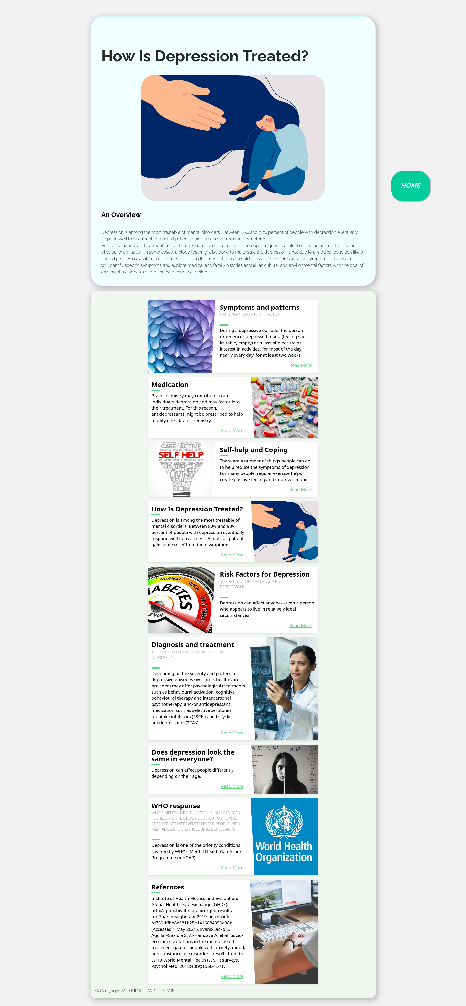

<!DOCTYPE html>

<html lang="en">

<head>

<meta charset="UTF-8">

<meta http-equiv="X-UA-Compatible" content="IE=edge">

<meta name="viewport" content="width=device-width, initial-scale=1.0">

<title>How Is Depression Treated?</title>

<link rel="stylesheet" href="style.css">

</head>

<body>

<div id="title">

<div class="card">

<div class="topic">

<h1>How Is Depression Treated?</h1>

</div>

<img src="assets/treat.jpg" alt="">

<h2>An Overview</h2>

<div class="content">

<p>Depression is among the most treatable of mental disorders. Between 80% and 90% percent of people

with depression eventually respond well to treatment. Almost all patients gain some relief from

their symptoms.

<br>

Before a diagnosis or treatment, a health professional should conduct a thorough diagnostic

evaluation, including an interview and a physical examination. In some cases, a blood test might be

done to make sure the depression is not due to a medical condition like a thyroid problem or a

vitamin deficiency (reversing the medical cause would alleviate the depression-like symptoms). The

evaluation will identify specific symptoms and explore medical and family histories as well as

cultural and environmental factors with the goal of arriving at a diagnosis and planning a course of

action.

</p>

</div>

</div>

<div class="banner">

<div class="blog-card">

<div class="meta">

<div class="photo" style="background-image: url(assets/pattern.jpg)"></div>

<ul class="details">

<li class="author"><a href="#">IFTIKAR HUSSAIN</a></li>

<li class="date">Apr. 24, 2022</li>

<li class="tags">

<ul>

<li><a href="#">Learn</a></li>

<li><a href="#">more</a></li>

</ul>

</li>

</ul>

</div>

<div class="description">

<h1>Symptoms and patterns

</h1>

<h2>Opening a door to the future</h2>

<p> During a depressive episode, the person experiences depressed mood (feeling sad, irritable,

empty) or a

loss of pleasure or interest in activities, for most of the day, nearly every day, for at

least two weeks.

</p>

<p class="read-more">

<a href="./symtoms.html">Read More</a>

</p>

</div>

</div>

<div class="blog-card alt">

<div class="meta">

<div class="photo" style="background-image: url(assets/Medication.webp)">

</div>

<ul class="details">

<li class="author"><a href="#">IFTIKAR HUSSAIN</a></li>

<li class="date">July. 15, 2022</li>

<li class="tags">

<ul>

<li><a href="#">Learn</a></li>

<li><a href="#">more</a></li>

<li><a href="#"></a></li>

</ul>

</li>

</ul>

</div>

<div class="description">

<h1>Medication</h1>

<!-- <h2>depression</h2> -->

<p>Brain chemistry may contribute to an individual’s depression and may factor into their

treatment. For this

reason, antidepressants might be prescribed to help modify one’s brain chemistry.

</p>

<p class="read-more">

<a href="./medication.html">Read More</a>

</p>

</div>

</div>

<div class="blog-card">

<div class="meta">

<div class="photo" style="background-image: url(assets/help.jpg)">

</div>

<ul class="details">

<li class="author"><a href="#">IFTIKAR HUSSAIN</a></li>

<li class="date">Apr. 24, 2022</li>

<li class="tags">

<ul>

<li><a href="#">Learn</a></li>

<li><a href="#">more</a></li>

</ul>

</li>

</ul>

</div>

<div class="description">

<h1>Self-help and Coping

</h1>

<!-- <h2>Opening a door to the future</h2> -->

<p> There are a number of things people can do to help reduce the symptoms of depression. For

many people,

regular exercise helps create positive feeling and improves mood.

</p>

<p class="read-more">

<a href="./help.html">Read More</a>

</p>

</div>

</div>

<div class="blog-card alt">

<div class="meta">

<div class="photo" style="background-image: url(assets/treat.jpg)">

</div>

<ul class="details">

<li class="author"><a href="#">IFTIKAR HUSSAIN</a></li>

<li class="date">July. 15, 2022</li>

<li class="tags">

<ul>

<li><a href="#">Learn</a></li>

<li><a href="#">more</a></li>

<li><a href="#"></a></li>

</ul>

</li>

</ul>

</div>

<div class="description">

<h1>How Is Depression Treated?</h1>

<!-- <h2>depression</h2> -->

<p>Depression is among the most treatable of mental disorders. Between 80% and 90% percent of

people with

depression eventually respond well to treatment. Almost all patients gain some relief from

their symptoms.

</p>

<p class="read-more">

<a href="./treated.html">Read More</a>

</p>

</div>

</div>

<div class="blog-card">

<div class="meta">

<div class="photo" style="background-image: url(assets/risk.jpg)"></div>

<ul class="details">

<li class="author"><a href="#">IFTIKAR HUSSAIN</a></li>

<li class="date">Apr. 24, 2022</li>

<li class="tags">

<ul>

<li><a href="#">Learn</a></li>

<li><a href="#">more</a></li>

</ul>

</li>

</ul>

</div>

<div class="description">

<h1>Risk Factors for Depression

</h1>

<h2>Several factors can play a role in depression:</h2>

<!-- <h2>Opening a door to the future</h2> -->

<p> Depression can affect anyone—even a person who appears to live in relatively ideal

circumstances.

</p>

<p class="read-more">

<a href="./risk.html">Read More</a>

</p>

</div>

</div>

<div class="blog-card alt">

<div class="meta">

<div class="photo" style="background-image: url(assets/daignosin.jpg)">

</div>

<ul class="details">

<li class="author"><a href="#">IFTIKAR HUSSAIN</a></li>

<li class="date">July. 15, 2022</li>

<li class="tags">

<ul>

<li><a href="#">Learn</a></li>

<li><a href="#">more</a></li>

<li><a href="#"></a></li>

</ul>

</li>

</ul>

</div>

<div class="description">

<h1>Diagnosis and treatment</h1>

<h2>There are effective treatments for depression. </h2>

<p>Depending on the severity and pattern of depressive episodes over time, health-care providers

may offer

psychological treatments such as behavioural activation, cognitive behavioural therapy and

interpersonal

psychotherapy, and/or antidepressant medication such as selective serotonin reuptake

inhibitors (SSRIs) and

tricyclic antidepressants (TCAs). </p>

<p class="read-more">

<a href="./daignosis.html">Read More</a>

</p>

</div>

</div>

<div class="blog-card alt">

<div class="meta">

<div class="photo" style="background-image: url(assets/look.jpeg)">

</div>

<ul class="details">

<li class="author"><a href="#">IFTIKAR HUSSAIN</a></li>

<li class="date">July. 15, 2022</li>

<li class="tags">

<ul>

<li><a href="#">Learn</a></li>

<li><a href="#">more</a></li>

<li><a href="#"></a></li>

</ul>

</li>

</ul>

</div>

<div class="description">

<h1>Does depression look the same in everyone?</h1>

<!-- <h2>depression</h2> -->

<p>Depression can affect people differently, depending on their age.

</p>

<p class="read-more">

<a href="./look.html ">Read More</a>

</p>

</div>

</div>

<div class="blog-card alt">

<div class="meta">

<div class="photo" style="background-image: url(assets/who.jpg)">

</div>

<ul class="details">

<li class="author"><a href="#">IFTIKAR HUSSAIN</a></li>

<li class="date">July. 15, 2022</li>

<li class="tags">

<ul>

<li><a href="#">Learn</a></li>

<li><a href="#">more</a></li>

<li><a href="#"></a></li>

</ul>

</li>

</ul>

</div>

<div class="description">

<h1>WHO response</h1>

<h2>WHO’s Mental Health Action Plan 2013-2030 highlights the steps required to provide

appropriate

interventions for people with mental disorders including depression. </h2>

<p>Depression is one of the priority conditions covered by WHO’s Mental Health Gap Action

Programme (mhGAP).

</p>

<p class="read-more">

<a href="./who.html">Read More</a>

</p>

</div>

</div>

<div class="blog-card alt">

<div class="meta">

<div class="photo"

style="background-image: url(https://storage.googleapis.com/chydlx/codepen/blog-cards/image-2.jpg)">

</div>

<ul class="details">

<li class="author"><a href="#">Jane Doe</a></li>

<li class="date">July. 15, 2015</li>

<li class="tags">

<ul>

<li><a href="#">Learn</a></li>

<li><a href="#">more</a></li>

<li><a href="#"></a></li>

</ul>

</li>

</ul>

</div>

<div class="description">

<h1>Refernces</h1>

<!-- <h2>WHO’s Mental Health Action Plan 2013-2030 highlights the steps required to provide appropriate

interventions for people with mental disorders including depression. </h2> -->

<p>Institute of Health Metrics and Evaluation. Global Health Data Exchange (GHDx).

http://ghdx.healthdata.org/gbd-results-tool?params=gbd-api-2019-permalink/d780dffbe8a381b25e1416884959e88b

(Accessed 1 May 2021).

Evans-Lacko S, Aguilar-Gaxiola S, Al-Hamzawi A, et al. Socio-economic variations in the

mental health

treatment gap for people with anxiety, mood, and substance use disorders: results from the

WHO World Mental

Health (WMH) surveys. Psychol Med. 2018;48(9):1560-1571.

</p>

<p class="read-more">

<a href="./refer.html">Read More</a>

</p>

</div>

</div>

<footer>&copy Copyright 2022 MD IFTIKAR HUSSAIN </footer>

<a href="index.html" class="float">

<i class="fa fa-plus my-float">

<h2>HOME</h2>

</i>

</a>

</body>

</html>

# **RISK FACTORS FOR DEPRESSION**

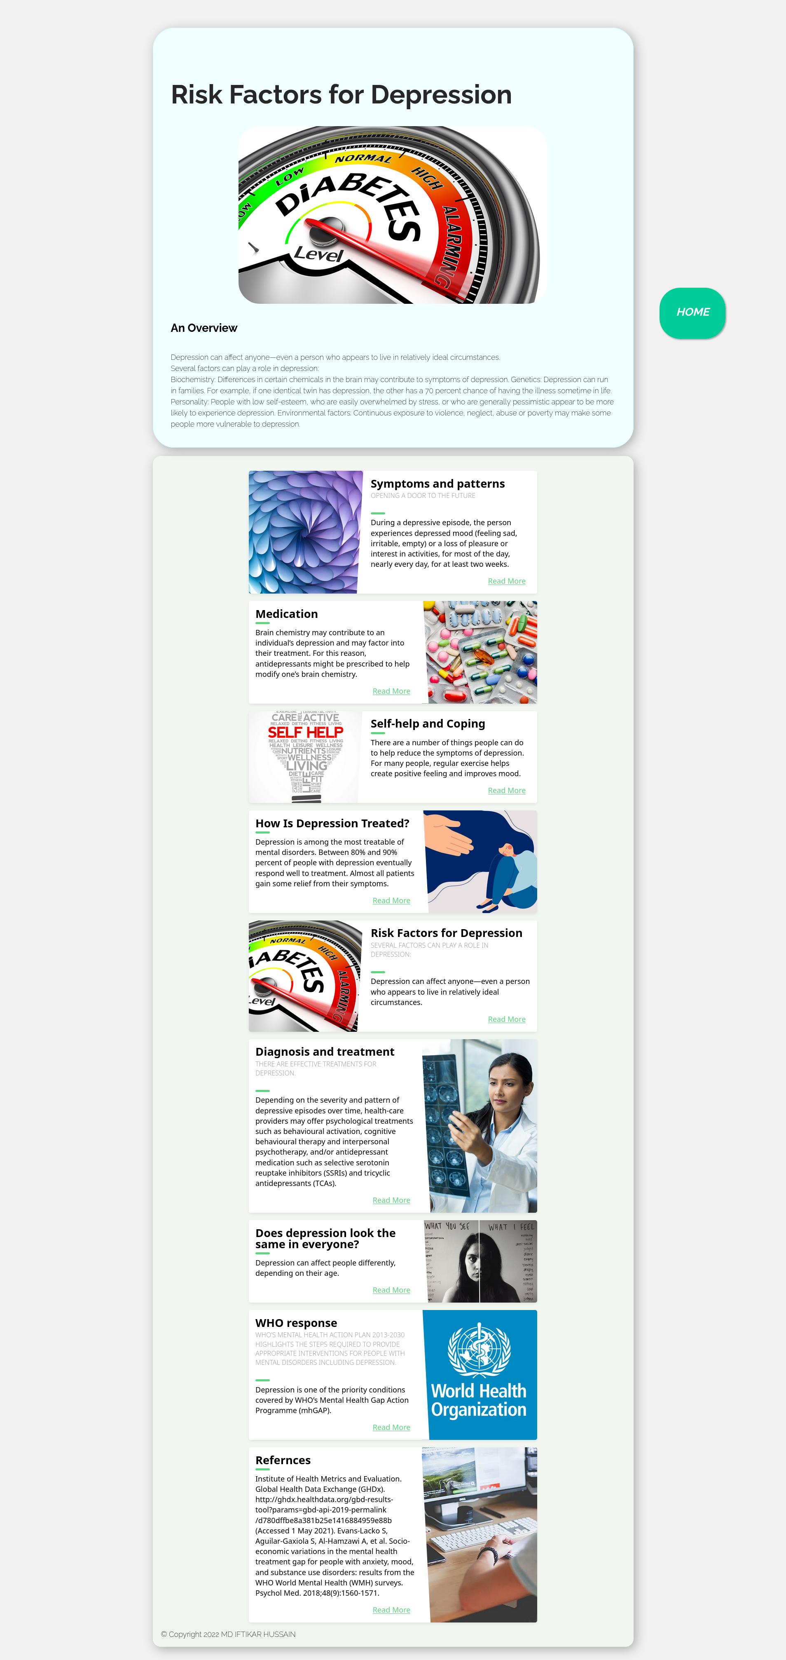

<!DOCTYPE html>

<html lang="en">

<head>

<meta charset="UTF-8">

<meta http-equiv="X-UA-Compatible" content="IE=edge">

<meta name="viewport" content="width=device-width, initial-scale=1.0">

<title>Risk Factors for Depression</title>

<link rel="stylesheet" href="style.css">

</head>

<body>

<div id="title">

<div class="card">

<div class="topic">

<h1>Risk Factors for Depression</h1>

</div>

<img src="assets/risk.jpg" alt="">

<h2>An Overview</h2>

<div class="content">

<p>Depression can affect anyone—even a person who appears to live in relatively ideal circumstances.

<br>

Several factors can play a role in depression:

<br>

Biochemistry: Differences in certain chemicals in the brain may contribute to symptoms of

depression.

Genetics: Depression can run in families. For example, if one identical twin has depression, the

other has a 70 percent chance of having the illness sometime in life.

Personality: People with low self-esteem, who are easily overwhelmed by stress, or who are generally

pessimistic appear to be more likely to experience depression.

Environmental factors: Continuous exposure to violence, neglect, abuse or poverty may make some

people more vulnerable to depression.

</p>

</div>

</div>

<div class="banner">

<div class="blog-card">

<div class="meta">

<div class="photo" style="background-image: url(assets/pattern.jpg)"></div>

<ul class="details">

<li class="author"><a href="#">IFTIKAR HUSSAIN</a></li>

<li class="date">Apr. 24, 2022</li>

<li class="tags">

<ul>

<li><a href="#">Learn</a></li>

<li><a href="#">more</a></li>

</ul>

</li>

</ul>

</div>

<div class="description">

<h1>Symptoms and patterns

</h1>

<h2>Opening a door to the future</h2>

<p> During a depressive episode, the person experiences depressed mood (feeling sad, irritable,

empty) or a

loss of pleasure or interest in activities, for most of the day, nearly every day, for at

least two weeks.

</p>

<p class="read-more">

<a href="./symtoms.html">Read More</a>

</p>

</div>

</div>

<div class="blog-card alt">

<div class="meta">

<div class="photo" style="background-image: url(assets/Medication.webp)">

</div>

<ul class="details">

<li class="author"><a href="#">IFTIKAR HUSSAIN</a></li>

<li class="date">July. 15, 2022</li>

<li class="tags">

<ul>

<li><a href="#">Learn</a></li>

<li><a href="#">more</a></li>

<li><a href="#"></a></li>

</ul>

</li>

</ul>

</div>

<div class="description">

<h1>Medication</h1>

<!-- <h2>depression</h2> -->

<p>Brain chemistry may contribute to an individual’s depression and may factor into their

treatment. For this

reason, antidepressants might be prescribed to help modify one’s brain chemistry.

</p>

<p class="read-more">

<a href="./medication.html">Read More</a>

</p>

</div>

</div>

<div class="blog-card">

<div class="meta">

<div class="photo" style="background-image: url(assets/help.jpg)">

</div>

<ul class="details">

<li class="author"><a href="#">IFTIKAR HUSSAIN</a></li>

<li class="date">Apr. 24, 2022</li>

<li class="tags">

<ul>

<li><a href="#">Learn</a></li>

<li><a href="#">more</a></li>

</ul>

</li>

</ul>

</div>

<div class="description">

<h1>Self-help and Coping

</h1>

<!-- <h2>Opening a door to the future</h2> -->

<p> There are a number of things people can do to help reduce the symptoms of depression. For

many people,

regular exercise helps create positive feeling and improves mood.

</p>

<p class="read-more">

<a href="./help.html">Read More</a>

</p>

</div>

</div>

<div class="blog-card alt">

<div class="meta">

<div class="photo" style="background-image: url(assets/treat.jpg)">

</div>

<ul class="details">

<li class="author"><a href="#">IFTIKAR HUSSAIN</a></li>

<li class="date">July. 15, 2022</li>

<li class="tags">

<ul>

<li><a href="#">Learn</a></li>

<li><a href="#">more</a></li>

<li><a href="#"></a></li>

</ul>

</li>

</ul>

</div>

<div class="description">

<h1>How Is Depression Treated?</h1>

<!-- <h2>depression</h2> -->

<p>Depression is among the most treatable of mental disorders. Between 80% and 90% percent of

people with

depression eventually respond well to treatment. Almost all patients gain some relief from

their symptoms.

</p>

<p class="read-more">

<a href="./treated.html">Read More</a>

</p>

</div>

</div>

<div class="blog-card">

<div class="meta">

<div class="photo" style="background-image: url(assets/risk.jpg)"></div>

<ul class="details">

<li class="author"><a href="#">IFTIKAR HUSSAIN</a></li>

<li class="date">Apr. 24, 2022</li>

<li class="tags">

<ul>

<li><a href="#">Learn</a></li>

<li><a href="#">more</a></li>

</ul>

</li>

</ul>

</div>

<div class="description">

<h1>Risk Factors for Depression

</h1>

<h2>Several factors can play a role in depression:</h2>

<!-- <h2>Opening a door to the future</h2> -->

<p> Depression can affect anyone—even a person who appears to live in relatively ideal

circumstances.

</p>

<p class="read-more">

<a href="./risk.html">Read More</a>

</p>

</div>

</div>

<div class="blog-card alt">

<div class="meta">

<div class="photo" style="background-image: url(assets/daignosin.jpg)">

</div>

<ul class="details">

<li class="author"><a href="#">IFTIKAR HUSSAIN</a></li>

<li class="date">July. 15, 2022</li>

<li class="tags">

<ul>

<li><a href="#">Learn</a></li>

<li><a href="#">more</a></li>

<li><a href="#"></a></li>

</ul>

</li>

</ul>

</div>

<div class="description">

<h1>Diagnosis and treatment</h1>

<h2>There are effective treatments for depression. </h2>

<p>Depending on the severity and pattern of depressive episodes over time, health-care providers

may offer

psychological treatments such as behavioural activation, cognitive behavioural therapy and

interpersonal

psychotherapy, and/or antidepressant medication such as selective serotonin reuptake

inhibitors (SSRIs) and

tricyclic antidepressants (TCAs). </p>

<p class="read-more">

<a href="./daignosis.html">Read More</a>

</p>

</div>

</div>

<div class="blog-card alt">

<div class="meta">

<div class="photo" style="background-image: url(assets/look.jpeg)">

</div>

<ul class="details">

<li class="author"><a href="#">IFTIKAR HUSSAIN</a></li>

<li class="date">July. 15, 2022</li>

<li class="tags">

<ul>

<li><a href="#">Learn</a></li>

<li><a href="#">more</a></li>

<li><a href="#"></a></li>

</ul>

</li>

</ul>

</div>

<div class="description">

<h1>Does depression look the same in everyone?</h1>

<!-- <h2>depression</h2> -->

<p>Depression can affect people differently, depending on their age.

</p>

<p class="read-more">

<a href="./look.html ">Read More</a>

</p>

</div>

</div>

<div class="blog-card alt">

<div class="meta">

<div class="photo" style="background-image: url(assets/who.jpg)">

</div>

<ul class="details">

<li class="author"><a href="#">IFTIKAR HUSSAIN</a></li>

<li class="date">July. 15, 2022</li>

<li class="tags">

<ul>

<li><a href="#">Learn</a></li>

<li><a href="#">more</a></li>

<li><a href="#"></a></li>

</ul>

</li>

</ul>

</div>

<div class="description">

<h1>WHO response</h1>

<h2>WHO’s Mental Health Action Plan 2013-2030 highlights the steps required to provide

appropriate

interventions for people with mental disorders including depression. </h2>

<p>Depression is one of the priority conditions covered by WHO’s Mental Health Gap Action

Programme (mhGAP).

</p>

<p class="read-more">

<a href="./who.html">Read More</a>

</p>

</div>

</div>

<div class="blog-card alt">

<div class="meta">

<div class="photo"

style="background-image: url(https://storage.googleapis.com/chydlx/codepen/blog-cards/image-2.jpg)">

</div>

<ul class="details">

<li class="author"><a href="#">Jane Doe</a></li>

<li class="date">July. 15, 2015</li>

<li class="tags">

<ul>

<li><a href="#">Learn</a></li>

<li><a href="#">more</a></li>

<li><a href="#"></a></li>

</ul>

</li>

</ul>

</div>

<div class="description">

<h1>Refernces</h1>

<!-- <h2>WHO’s Mental Health Action Plan 2013-2030 highlights the steps required to provide appropriate

interventions for people with mental disorders including depression. </h2> -->

<p>Institute of Health Metrics and Evaluation. Global Health Data Exchange (GHDx).

http://ghdx.healthdata.org/gbd-results-tool?params=gbd-api-2019-permalink/d780dffbe8a381b25e1416884959e88b

(Accessed 1 May 2021).

Evans-Lacko S, Aguilar-Gaxiola S, Al-Hamzawi A, et al. Socio-economic variations in the

mental health

treatment gap for people with anxiety, mood, and substance use disorders: results from the

WHO World Mental

Health (WMH) surveys. Psychol Med. 2018;48(9):1560-1571.

</p>

<p class="read-more">

<a href="./refer.html">Read More</a>

</p>

</div>

</div>

<footer>&copy Copyright 2022 MD IFTIKAR HUSSAIN </footer>

<a href="index.html" class="float">

<i class="fa fa-plus my-float">

<h2>HOME</h2>

</i>

</a>

</body>

</html>

# **DIAGNOSIS AND TREATMENT**

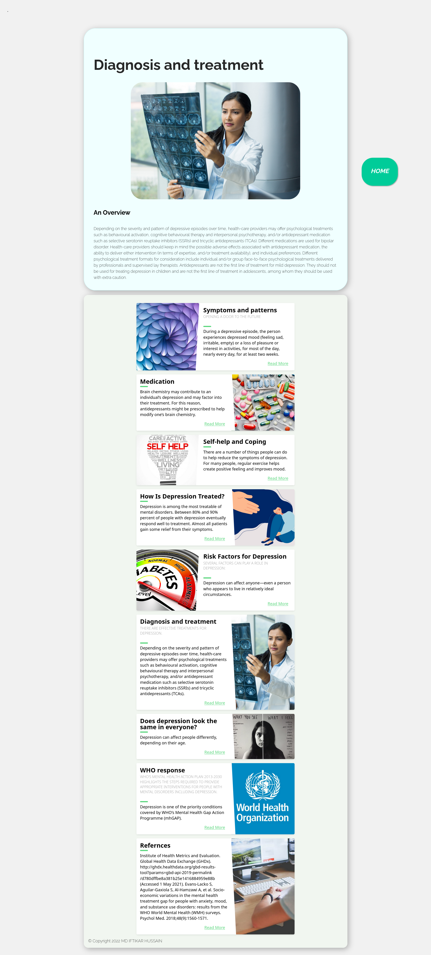

<!DOCTYPE html>

<html lang="en">

<head>

<meta charset="UTF-8">

<meta http-equiv="X-UA-Compatible" content="IE=edge">

<meta name="viewport" content="width=device-width, initial-scale=1.0">

<title>Diagnosis and treatment</title>

<link rel="stylesheet" href="style.css">

</head>

<body>

<div id="title">

<div class="card">

<div class="topic">

<h1>Diagnosis and treatment

</h1>

</div>

<img src="assets/daignosin.jpg" alt="">

<h2>An Overview</h2>

<div class="content">

<p>Depending on the severity and pattern of depressive episodes over time, health-care providers may offer

psychological treatments such as behavioural activation, cognitive behavioural therapy and interpersonal

psychotherapy, and/or antidepressant medication such as selective serotonin reuptake inhibitors (SSRIs) and

tricyclic antidepressants (TCAs). Different medications are used for bipolar disorder. Health-care providers

should keep in mind the possible adverse effects associated with antidepressant medication, the ability to

deliver either intervention (in terms of expertise, and/or treatment availability), and individual

preferences. Different psychological treatment formats for consideration include individual and/or group

face-to-face psychological treatments delivered by professionals and supervised lay therapists.

Antidepressants are not the first line of treatment for mild depression. They should not be used for treating

depression in children and are not the first line of treatment in adolescents, among whom they should be used

with extra caution.

</p>

</div>

</div>

<div class="banner">

<div class="blog-card">

<div class="meta">

<div class="photo" style="background-image: url(assets/pattern.jpg)"></div>

<ul class="details">

<li class="author"><a href="#">IFTIKAR HUSSAIN</a></li>

<li class="date">Apr. 24, 2022</li>

<li class="tags">

<ul>

<li><a href="#">Learn</a></li>

<li><a href="#">more</a></li>

</ul>

</li>

</ul>

</div>

<div class="description">

<h1>Symptoms and patterns

</h1>

<h2>Opening a door to the future</h2>

<p> During a depressive episode, the person experiences depressed mood (feeling sad, irritable,

empty) or a

loss of pleasure or interest in activities, for most of the day, nearly every day, for at

least two weeks.

</p>

<p class="read-more">

<a href="./symtoms.html">Read More</a>

</p>

</div>

</div>

<div class="blog-card alt">

<div class="meta">

<div class="photo" style="background-image: url(assets/Medication.webp)">

</div>

<ul class="details">

<li class="author"><a href="#">IFTIKAR HUSSAIN</a></li>

<li class="date">July. 15, 2022</li>

<li class="tags">

<ul>

<li><a href="#">Learn</a></li>

<li><a href="#">more</a></li>

<li><a href="#"></a></li>

</ul>

</li>

</ul>

</div>

<div class="description">

<h1>Medication</h1>

<!-- <h2>depression</h2> -->

<p>Brain chemistry may contribute to an individual’s depression and may factor into their

treatment. For this

reason, antidepressants might be prescribed to help modify one’s brain chemistry.

</p>

<p class="read-more">

<a href="./medication.html">Read More</a>

</p>

</div>

</div>

<div class="blog-card">

<div class="meta">

<div class="photo" style="background-image: url(assets/help.jpg)">

</div>

<ul class="details">

<li class="author"><a href="#">IFTIKAR HUSSAIN</a></li>

<li class="date">Apr. 24, 2022</li>

<li class="tags">

<ul>

<li><a href="#">Learn</a></li>

<li><a href="#">more</a></li>

</ul>

</li>

</ul>

</div>

<div class="description">

<h1>Self-help and Coping

</h1>

<!-- <h2>Opening a door to the future</h2> -->

<p> There are a number of things people can do to help reduce the symptoms of depression. For

many people,

regular exercise helps create positive feeling and improves mood.

</p>

<p class="read-more">

<a href="./help.html">Read More</a>

</p>

</div>

</div>

<div class="blog-card alt">

<div class="meta">

<div class="photo" style="background-image: url(assets/treat.jpg)">

</div>

<ul class="details">

<li class="author"><a href="#">IFTIKAR HUSSAIN</a></li>

<li class="date">July. 15, 2022</li>

<li class="tags">

<ul>

<li><a href="#">Learn</a></li>

<li><a href="#">more</a></li>

<li><a href="#"></a></li>

</ul>

</li>

</ul>

</div>

<div class="description">

<h1>How Is Depression Treated?</h1>

<!-- <h2>depression</h2> -->

<p>Depression is among the most treatable of mental disorders. Between 80% and 90% percent of

people with

depression eventually respond well to treatment. Almost all patients gain some relief from

their symptoms.

</p>

<p class="read-more">

<a href="./treated.html">Read More</a>

</p>

</div>

</div>

<div class="blog-card">

<div class="meta">

<div class="photo" style="background-image: url(assets/risk.jpg)"></div>

<ul class="details">

<li class="author"><a href="#">IFTIKAR HUSSAIN</a></li>

<li class="date">Apr. 24, 2022</li>

<li class="tags">

<ul>

<li><a href="#">Learn</a></li>

<li><a href="#">more</a></li>

</ul>

</li>

</ul>

</div>

<div class="description">

<h1>Risk Factors for Depression

</h1>

<h2>Several factors can play a role in depression:</h2>

<!-- <h2>Opening a door to the future</h2> -->

<p> Depression can affect anyone—even a person who appears to live in relatively ideal

circumstances.

</p>

<p class="read-more">

<a href="./risk.html">Read More</a>

</p>

</div>

</div>

<div class="blog-card alt">

<div class="meta">

<div class="photo" style="background-image: url(assets/daignosin.jpg)">

</div>

<ul class="details">

<li class="author"><a href="#">IFTIKAR HUSSAIN</a></li>

<li class="date">July. 15, 2022</li>

<li class="tags">

<ul>

<li><a href="#">Learn</a></li>

<li><a href="#">more</a></li>

<li><a href="#"></a></li>

</ul>

</li>

</ul>

</div>

<div class="description">

<h1>Diagnosis and treatment</h1>

<h2>There are effective treatments for depression. </h2>

<p>Depending on the severity and pattern of depressive episodes over time, health-care providers

may offer

psychological treatments such as behavioural activation, cognitive behavioural therapy and

interpersonal

psychotherapy, and/or antidepressant medication such as selective serotonin reuptake

inhibitors (SSRIs) and

tricyclic antidepressants (TCAs). </p>

<p class="read-more">

<a href="./daignosis.html">Read More</a>

</p>

</div>

</div>

<div class="blog-card alt">

<div class="meta">

<div class="photo" style="background-image: url(assets/look.jpeg)">

</div>

<ul class="details">

<li class="author"><a href="#">IFTIKAR HUSSAIN</a></li>

<li class="date">July. 15, 2022</li>

<li class="tags">

<ul>

<li><a href="#">Learn</a></li>

<li><a href="#">more</a></li>

<li><a href="#"></a></li>

</ul>

</li>

</ul>

</div>

<div class="description">

<h1>Does depression look the same in everyone?</h1>

<!-- <h2>depression</h2> -->

<p>Depression can affect people differently, depending on their age.

</p>

<p class="read-more">

<a href="./look.html ">Read More</a>

</p>

</div>

</div>

<div class="blog-card alt">

<div class="meta">

<div class="photo" style="background-image: url(assets/who.jpg)">

</div>

<ul class="details">

<li class="author"><a href="#">IFTIKAR HUSSAIN</a></li>

<li class="date">July. 15, 2022</li>

<li class="tags">

<ul>

<li><a href="#">Learn</a></li>

<li><a href="#">more</a></li>

<li><a href="#"></a></li>

</ul>

</li>

</ul>

</div>

<div class="description">

<h1>WHO response</h1>

<h2>WHO’s Mental Health Action Plan 2013-2030 highlights the steps required to provide

appropriate

interventions for people with mental disorders including depression. </h2>

<p>Depression is one of the priority conditions covered by WHO’s Mental Health Gap Action

Programme (mhGAP).

</p>

<p class="read-more">

<a href="./who.html">Read More</a>

</p>

</div>

</div>

<div class="blog-card alt">

<div class="meta">

<div class="photo"

style="background-image: url(https://storage.googleapis.com/chydlx/codepen/blog-cards/image-2.jpg)">

</div>

<ul class="details">

<li class="author"><a href="#">Jane Doe</a></li>

<li class="date">July. 15, 2015</li>

<li class="tags">

<ul>

<li><a href="#">Learn</a></li>

<li><a href="#">more</a></li>

<li><a href="#"></a></li>

</ul>

</li>

</ul>

</div>

<div class="description">

<h1>Refernces</h1>

<!-- <h2>WHO’s Mental Health Action Plan 2013-2030 highlights the steps required to provide appropriate

interventions for people with mental disorders including depression. </h2> -->

<p>Institute of Health Metrics and Evaluation. Global Health Data Exchange (GHDx).

http://ghdx.healthdata.org/gbd-results-tool?params=gbd-api-2019-permalink/d780dffbe8a381b25e1416884959e88b

(Accessed 1 May 2021).

Evans-Lacko S, Aguilar-Gaxiola S, Al-Hamzawi A, et al. Socio-economic variations in the

mental health

treatment gap for people with anxiety, mood, and substance use disorders: results from the

WHO World Mental

Health (WMH) surveys. Psychol Med. 2018;48(9):1560-1571.

</p>

<p class="read-more">

<a href="./refer.html">Read More</a>

</p>

</div>

</div>

<footer>&copy Copyright 2022 MD IFTIKAR HUSSAIN </footer>

<a href="index.html" class="float">

<i class="fa fa-plus my-float">

<h2>HOME</h2>

</i>

</a>

</body>

</html>

# **DOES DEPRESSION LOOK THE SAME IN EVERYONE?**

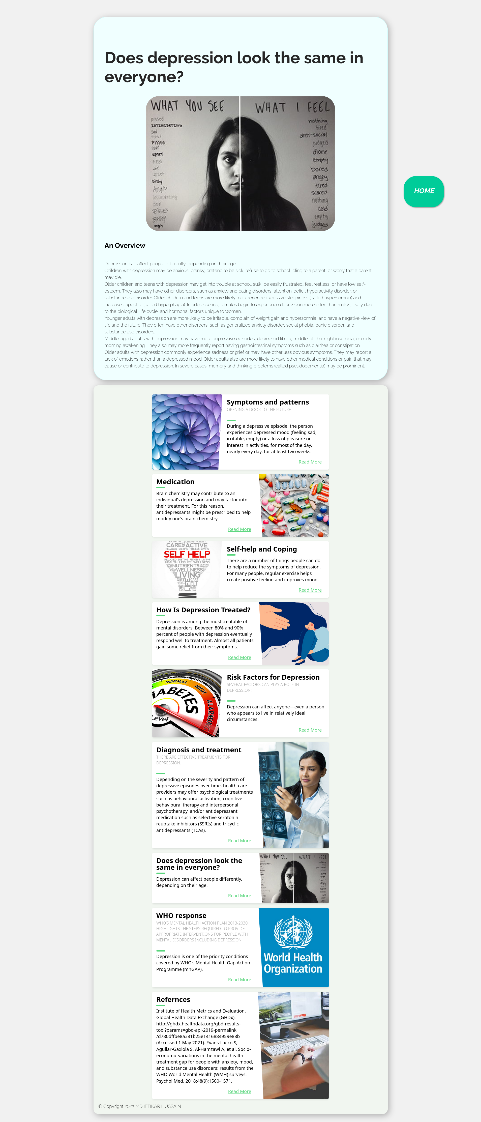

<!DOCTYPE html>

<html lang="en">

<head>

<meta charset="UTF-8">

<meta http-equiv="X-UA-Compatible" content="IE=edge">

<meta name="viewport" content="width=device-width, initial-scale=1.0">

<title>Does depression look the same in everyone?</title>

<link rel="stylesheet" href="style.css">

</head>

<body>

<div id="title">

<div class="card">

<div class="topic">

<h1>Does depression look the same in everyone?</h1>

</div>

<img src="assets/look.jpeg" alt="">

<h2>An Overview</h2>

<div class="content">

<p>Depression can affect people differently, depending on their age.

<br>

Children with depression may be anxious, cranky, pretend to be sick, refuse to go to school, cling

to a parent, or worry that a parent may die.

<br>

Older children and teens with depression may get into trouble at school, sulk, be easily frustrated‚

feel restless, or have low self-esteem. They also may have other disorders, such as anxiety and

eating disorders, attention-deficit hyperactivity disorder, or substance use disorder. Older

children and teens are more likely to experience excessive sleepiness (called hypersomnia) and

increased appetite (called hyperphagia). In adolescence, females begin to experience depression more

often than males, likely due to the biological, life cycle, and hormonal factors unique to women.

<br>

Younger adults with depression are more likely to be irritable, complain of weight gain and

hypersomnia, and have a negative view of life and the future. They often have other disorders, such

as generalized anxiety disorder, social phobia, panic disorder, and substance use disorders.

<br>

Middle-aged adults with depression may have more depressive episodes, decreased libido,

middle-of-the-night insomnia, or early morning awakening. They also may more frequently report

having gastrointestinal symptoms such as diarrhea or constipation.

<br>

Older adults with depression commonly experience sadness or grief or may have other less obvious

symptoms. They may report a lack of emotions rather than a depressed mood. Older adults also are

more likely to have other medical conditions or pain that may cause or contribute to depression. In

severe cases, memory and thinking problems (called pseudodementia) may be prominent.

</p>

</div>

</div>

<div class="banner">

<div class="blog-card">

<div class="meta">

<div class="photo" style="background-image: url(assets/pattern.jpg)"></div>

<ul class="details">

<li class="author"><a href="#">IFTIKAR HUSSAIN</a></li>

<li class="date">Apr. 24, 2022</li>

<li class="tags">

<ul>

<li><a href="#">Learn</a></li>

<li><a href="#">more</a></li>

</ul>

</li>

</ul>

</div>

<div class="description">

<h1>Symptoms and patterns

</h1>

<h2>Opening a door to the future</h2>

<p> During a depressive episode, the person experiences depressed mood (feeling sad, irritable,

empty) or a

loss of pleasure or interest in activities, for most of the day, nearly every day, for at

least two weeks.

</p>

<p class="read-more">

<a href="./symtoms.html">Read More</a>

</p>

</div>

</div>

<div class="blog-card alt">

<div class="meta">

<div class="photo" style="background-image: url(assets/Medication.webp)">

</div>

<ul class="details">

<li class="author"><a href="#">IFTIKAR HUSSAIN</a></li>

<li class="date">July. 15, 2022</li>

<li class="tags">

<ul>

<li><a href="#">Learn</a></li>

<li><a href="#">more</a></li>

<li><a href="#"></a></li>

</ul>

</li>

</ul>

</div>

<div class="description">

<h1>Medication</h1>

<!-- <h2>depression</h2> -->

<p>Brain chemistry may contribute to an individual’s depression and may factor into their

treatment. For this

reason, antidepressants might be prescribed to help modify one’s brain chemistry.

</p>

<p class="read-more">

<a href="./medication.html">Read More</a>

</p>

</div>

</div>

<div class="blog-card">

<div class="meta">

<div class="photo" style="background-image: url(assets/help.jpg)">

</div>

<ul class="details">

<li class="author"><a href="#">IFTIKAR HUSSAIN</a></li>

<li class="date">Apr. 24, 2022</li>

<li class="tags">

<ul>

<li><a href="#">Learn</a></li>

<li><a href="#">more</a></li>

</ul>

</li>

</ul>

</div>

<div class="description">

<h1>Self-help and Coping

</h1>

<!-- <h2>Opening a door to the future</h2> -->

<p> There are a number of things people can do to help reduce the symptoms of depression. For

many people,

regular exercise helps create positive feeling and improves mood.

</p>

<p class="read-more">

<a href="./help.html">Read More</a>

</p>

</div>

</div>

<div class="blog-card alt">

<div class="meta">

<div class="photo" style="background-image: url(assets/treat.jpg)">

</div>

<ul class="details">

<li class="author"><a href="#">IFTIKAR HUSSAIN</a></li>

<li class="date">July. 15, 2022</li>

<li class="tags">

<ul>

<li><a href="#">Learn</a></li>

<li><a href="#">more</a></li>

<li><a href="#"></a></li>

</ul>

</li>

</ul>

</div>

<div class="description">

<h1>How Is Depression Treated?</h1>

<!-- <h2>depression</h2> -->

<p>Depression is among the most treatable of mental disorders. Between 80% and 90% percent of

people with

depression eventually respond well to treatment. Almost all patients gain some relief from

their symptoms.

</p>

<p class="read-more">

<a href="./treated.html">Read More</a>

</p>

</div>

</div>

<div class="blog-card">

<div class="meta">

<div class="photo" style="background-image: url(assets/risk.jpg)"></div>

<ul class="details">

<li class="author"><a href="#">IFTIKAR HUSSAIN</a></li>

<li class="date">Apr. 24, 2022</li>

<li class="tags">

<ul>

<li><a href="#">Learn</a></li>

<li><a href="#">more</a></li>

</ul>

</li>

</ul>

</div>

<div class="description">

<h1>Risk Factors for Depression

</h1>

<h2>Several factors can play a role in depression:</h2>

<!-- <h2>Opening a door to the future</h2> -->

<p> Depression can affect anyone—even a person who appears to live in relatively ideal

circumstances.

</p>

<p class="read-more">

<a href="./risk.html">Read More</a>

</p>

</div>

</div>

<div class="blog-card alt">

<div class="meta">

<div class="photo" style="background-image: url(assets/daignosin.jpg)">

</div>

<ul class="details">

<li class="author"><a href="#">IFTIKAR HUSSAIN</a></li>

<li class="date">July. 15, 2022</li>

<li class="tags">

<ul>

<li><a href="#">Learn</a></li>

<li><a href="#">more</a></li>

<li><a href="#"></a></li>

</ul>

</li>

</ul>

</div>

<div class="description">

<h1>Diagnosis and treatment</h1>

<h2>There are effective treatments for depression. </h2>

<p>Depending on the severity and pattern of depressive episodes over time, health-care providers

may offer

psychological treatments such as behavioural activation, cognitive behavioural therapy and

interpersonal

psychotherapy, and/or antidepressant medication such as selective serotonin reuptake

inhibitors (SSRIs) and

tricyclic antidepressants (TCAs). </p>

<p class="read-more">

<a href="./daignosis.html">Read More</a>

</p>

</div>

</div>

<div class="blog-card alt">

<div class="meta">

<div class="photo" style="background-image: url(assets/look.jpeg)">

</div>

<ul class="details">

<li class="author"><a href="#">IFTIKAR HUSSAIN</a></li>

<li class="date">July. 15, 2022</li>

<li class="tags">

<ul>

<li><a href="#">Learn</a></li>

<li><a href="#">more</a></li>

<li><a href="#"></a></li>

</ul>

</li>

</ul>

</div>

<div class="description">

<h1>Does depression look the same in everyone?</h1>

<!-- <h2>depression</h2> -->

<p>Depression can affect people differently, depending on their age.

</p>

<p class="read-more">

<a href="./look.html ">Read More</a>

</p>

</div>

</div>

<div class="blog-card alt">

<div class="meta">

<div class="photo" style="background-image: url(assets/who.jpg)">

</div>

<ul class="details">

<li class="author"><a href="#">IFTIKAR HUSSAIN</a></li>

<li class="date">July. 15, 2022</li>

<li class="tags">

<ul>

<li><a href="#">Learn</a></li>

<li><a href="#">more</a></li>

<li><a href="#"></a></li>

</ul>

</li>

</ul>

</div>

<div class="description">

<h1>WHO response</h1>

<h2>WHO’s Mental Health Action Plan 2013-2030 highlights the steps required to provide

appropriate

interventions for people with mental disorders including depression. </h2>

<p>Depression is one of the priority conditions covered by WHO’s Mental Health Gap Action

Programme (mhGAP).

</p>

<p class="read-more">

<a href="./who.html">Read More</a>

</p>

</div>

</div>

<div class="blog-card alt">

<div class="meta">

<div class="photo"

style="background-image: url(https://storage.googleapis.com/chydlx/codepen/blog-cards/image-2.jpg)">

</div>

<ul class="details">

<li class="author"><a href="#">Jane Doe</a></li>

<li class="date">July. 15, 2015</li>

<li class="tags">

<ul>

<li><a href="#">Learn</a></li>

<li><a href="#">more</a></li>

<li><a href="#"></a></li>

</ul>

</li>

</ul>

</div>

<div class="description">

<h1>Refernces</h1>

<!-- <h2>WHO’s Mental Health Action Plan 2013-2030 highlights the steps required to provide appropriate

interventions for people with mental disorders including depression. </h2> -->

<p>Institute of Health Metrics and Evaluation. Global Health Data Exchange (GHDx).

http://ghdx.healthdata.org/gbd-results-tool?params=gbd-api-2019-permalink/d780dffbe8a381b25e1416884959e88b

(Accessed 1 May 2021).

Evans-Lacko S, Aguilar-Gaxiola S, Al-Hamzawi A, et al. Socio-economic variations in the

mental health

treatment gap for people with anxiety, mood, and substance use disorders: results from the

WHO World Mental

Health (WMH) surveys. Psychol Med. 2018;48(9):1560-1571.

</p>

<p class="read-more">

<a href="./refer.html">Read More</a>

</p>

</div>

</div>

<footer>&copy Copyright 2022 MD IFTIKAR HUSSAIN </footer>

<a href="index.html" class="float">

<i class="fa fa-plus my-float">

<h2>HOME</h2>

</i>

</a>

</body>

</html>

# **WHO RESPONSE**

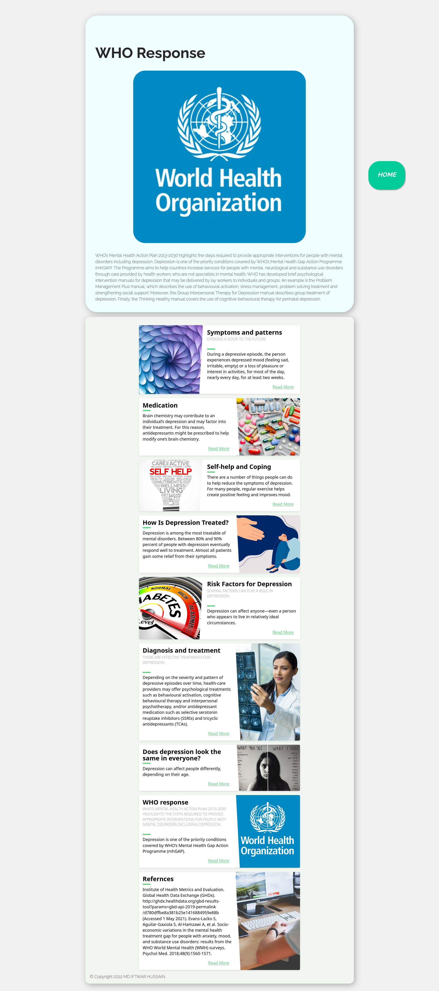

<!DOCTYPE html>

<html lang="en">

<head>

<meta charset="UTF-8">

<meta http-equiv="X-UA-Compatible" content="IE=edge">

<meta name="viewport" content="width=device-width, initial-scale=1.0">

<title>WHO response</title>

<link rel="stylesheet" href="style.css">

</head>

<body>

<div id="title">

<div class="card">

<div class="topic">

<h1>WHO Response

</h1>

</div>

<img src="assets/who.jpg" alt="">

<!-- <h2>An Overview</h2> -->

<div class="content">

<p>WHO’s Mental Health Action Plan 2013-2030 highlights the steps required to provide appropriate interventions

for people with mental disorders including depression.

Depression is one of the priority conditions covered by WHO’s Mental Health Gap Action Programme (mhGAP). The

Programme aims to help countries increase services for people with mental, neurological and substance use

disorders through care provided by health workers who are not specialists in mental health.

WHO has developed brief psychological intervention manuals for depression that may be delivered by lay workers

to individuals and groups. An example is the Problem Management Plus manual, which describes the use of

behavioural activation, stress management, problem solving treatment and strengthening social support.

Moreover, the Group Interpersonal Therapy for Depression manual describes group treatment of depression.

Finally, the Thinking Healthy manual covers the use of cognitive-behavioural therapy for perinatal depression.

</p>

</div>

</div>

<div class="banner">

<div class="blog-card">

<div class="meta">

<div class="photo" style="background-image: url(assets/pattern.jpg)"></div>

<ul class="details">

<li class="author"><a href="#">IFTIKAR HUSSAIN</a></li>

<li class="date">Apr. 24, 2022</li>

<li class="tags">

<ul>

<li><a href="#">Learn</a></li>

<li><a href="#">more</a></li>

</ul>

</li>

</ul>

</div>

<div class="description">

<h1>Symptoms and patterns

</h1>

<h2>Opening a door to the future</h2>

<p> During a depressive episode, the person experiences depressed mood (feeling sad, irritable,

empty) or a

loss of pleasure or interest in activities, for most of the day, nearly every day, for at

least two weeks.

</p>

<p class="read-more">

<a href="./symtoms.html">Read More</a>

</p>

</div>

</div>

<div class="blog-card alt">

<div class="meta">

<div class="photo" style="background-image: url(assets/Medication.webp)">

</div>

<ul class="details">

<li class="author"><a href="#">IFTIKAR HUSSAIN</a></li>

<li class="date">July. 15, 2022</li>

<li class="tags">

<ul>

<li><a href="#">Learn</a></li>

<li><a href="#">more</a></li>

<li><a href="#"></a></li>

</ul>

</li>

</ul>

</div>

<div class="description">

<h1>Medication</h1>

<!-- <h2>depression</h2> -->

<p>Brain chemistry may contribute to an individual’s depression and may factor into their

treatment. For this

reason, antidepressants might be prescribed to help modify one’s brain chemistry.

</p>

<p class="read-more">

<a href="./medication.html">Read More</a>

</p>

</div>

</div>

<div class="blog-card">

<div class="meta">

<div class="photo" style="background-image: url(assets/help.jpg)">

</div>

<ul class="details">

<li class="author"><a href="#">IFTIKAR HUSSAIN</a></li>

<li class="date">Apr. 24, 2022</li>

<li class="tags">

<ul>

<li><a href="#">Learn</a></li>

<li><a href="#">more</a></li>

</ul>

</li>

</ul>

</div>

<div class="description">

<h1>Self-help and Coping

</h1>

<!-- <h2>Opening a door to the future</h2> -->

<p> There are a number of things people can do to help reduce the symptoms of depression. For

many people,

regular exercise helps create positive feeling and improves mood.

</p>

<p class="read-more">

<a href="./help.html">Read More</a>

</p>

</div>

</div>

<div class="blog-card alt">

<div class="meta">

<div class="photo" style="background-image: url(assets/treat.jpg)">

</div>

<ul class="details">

<li class="author"><a href="#">IFTIKAR HUSSAIN</a></li>

<li class="date">July. 15, 2022</li>

<li class="tags">

<ul>

<li><a href="#">Learn</a></li>

<li><a href="#">more</a></li>

<li><a href="#"></a></li>

</ul>

</li>

</ul>

</div>

<div class="description">

<h1>How Is Depression Treated?</h1>

<!-- <h2>depression</h2> -->

<p>Depression is among the most treatable of mental disorders. Between 80% and 90% percent of

people with

depression eventually respond well to treatment. Almost all patients gain some relief from

their symptoms.

</p>

<p class="read-more">

<a href="./treated.html">Read More</a>

</p>

</div>

</div>

<div class="blog-card">

<div class="meta">

<div class="photo" style="background-image: url(assets/risk.jpg)"></div>

<ul class="details">

<li class="author"><a href="#">IFTIKAR HUSSAIN</a></li>

<li class="date">Apr. 24, 2022</li>

<li class="tags">

<ul>

<li><a href="#">Learn</a></li>

<li><a href="#">more</a></li>

</ul>

</li>

</ul>

</div>

<div class="description">

<h1>Risk Factors for Depression

</h1>

<h2>Several factors can play a role in depression:</h2>

<!-- <h2>Opening a door to the future</h2> -->

<p> Depression can affect anyone—even a person who appears to live in relatively ideal

circumstances.

</p>

<p class="read-more">

<a href="./risk.html">Read More</a>

</p>

</div>

</div>

<div class="blog-card alt">

<div class="meta">

<div class="photo" style="background-image: url(assets/daignosin.jpg)">

</div>

<ul class="details">

<li class="author"><a href="#">IFTIKAR HUSSAIN</a></li>

<li class="date">July. 15, 2022</li>

<li class="tags">

<ul>

<li><a href="#">Learn</a></li>

<li><a href="#">more</a></li>

<li><a href="#"></a></li>

</ul>

</li>

</ul>

</div>

<div class="description">

<h1>Diagnosis and treatment</h1>

<h2>There are effective treatments for depression. </h2>

<p>Depending on the severity and pattern of depressive episodes over time, health-care providers

may offer

psychological treatments such as behavioural activation, cognitive behavioural therapy and

interpersonal

psychotherapy, and/or antidepressant medication such as selective serotonin reuptake

inhibitors (SSRIs) and

tricyclic antidepressants (TCAs). </p>

<p class="read-more">

<a href="./daignosis.html">Read More</a>

</p>

</div>

</div>

<div class="blog-card alt">

<div class="meta">

<div class="photo" style="background-image: url(assets/look.jpeg)">

</div>

<ul class="details">

<li class="author"><a href="#">IFTIKAR HUSSAIN</a></li>

<li class="date">July. 15, 2022</li>

<li class="tags">

<ul>

<li><a href="#">Learn</a></li>

<li><a href="#">more</a></li>

<li><a href="#"></a></li>

</ul>

</li>

</ul>

</div>

<div class="description">

<h1>Does depression look the same in everyone?</h1>

<!-- <h2>depression</h2> -->

<p>Depression can affect people differently, depending on their age.

</p>

<p class="read-more">

<a href="./look.html ">Read More</a>

</p>

</div>

</div>

<div class="blog-card alt">

<div class="meta">

<div class="photo" style="background-image: url(assets/who.jpg)">

</div>

<ul class="details">

<li class="author"><a href="#">IFTIKAR HUSSAIN</a></li>

<li class="date">July. 15, 2022</li>

<li class="tags">

<ul>

<li><a href="#">Learn</a></li>

<li><a href="#">more</a></li>

<li><a href="#"></a></li>

</ul>

</li>

</ul>

</div>

<div class="description">

<h1>WHO response</h1>

<h2>WHO’s Mental Health Action Plan 2013-2030 highlights the steps required to provide

appropriate

interventions for people with mental disorders including depression. </h2>

<p>Depression is one of the priority conditions covered by WHO’s Mental Health Gap Action

Programme (mhGAP).

</p>

<p class="read-more">

<a href="./who.html">Read More</a>

</p>

</div>

</div>

<div class="blog-card alt">

<div class="meta">

<div class="photo"

style="background-image: url(https://storage.googleapis.com/chydlx/codepen/blog-cards/image-2.jpg)">

</div>

<ul class="details">

<li class="author"><a href="#">Jane Doe</a></li>

<li class="date">July. 15, 2015</li>

<li class="tags">

<ul>

<li><a href="#">Learn</a></li>

<li><a href="#">more</a></li>

<li><a href="#"></a></li>

</ul>

</li>

</ul>

</div>

<div class="description">

<h1>Refernces</h1>

<!-- <h2>WHO’s Mental Health Action Plan 2013-2030 highlights the steps required to provide appropriate

interventions for people with mental disorders including depression. </h2> -->

<p>Institute of Health Metrics and Evaluation. Global Health Data Exchange (GHDx).

http://ghdx.healthdata.org/gbd-results-tool?params=gbd-api-2019-permalink/d780dffbe8a381b25e1416884959e88b

(Accessed 1 May 2021).

Evans-Lacko S, Aguilar-Gaxiola S, Al-Hamzawi A, et al. Socio-economic variations in the

mental health

treatment gap for people with anxiety, mood, and substance use disorders: results from the

WHO World Mental

Health (WMH) surveys. Psychol Med. 2018;48(9):1560-1571.

</p>

<p class="read-more">

<a href="./refer.html">Read More</a>

</p>

</div>

</div>

<footer>&copy Copyright 2022 MD IFTIKAR HUSSAIN </footer>

<a href="index.html" class="float">

<i class="fa fa-plus my-float">

<h2>HOME</h2>

</i>

</a>

</body>

</html>

# **REFERNCES**

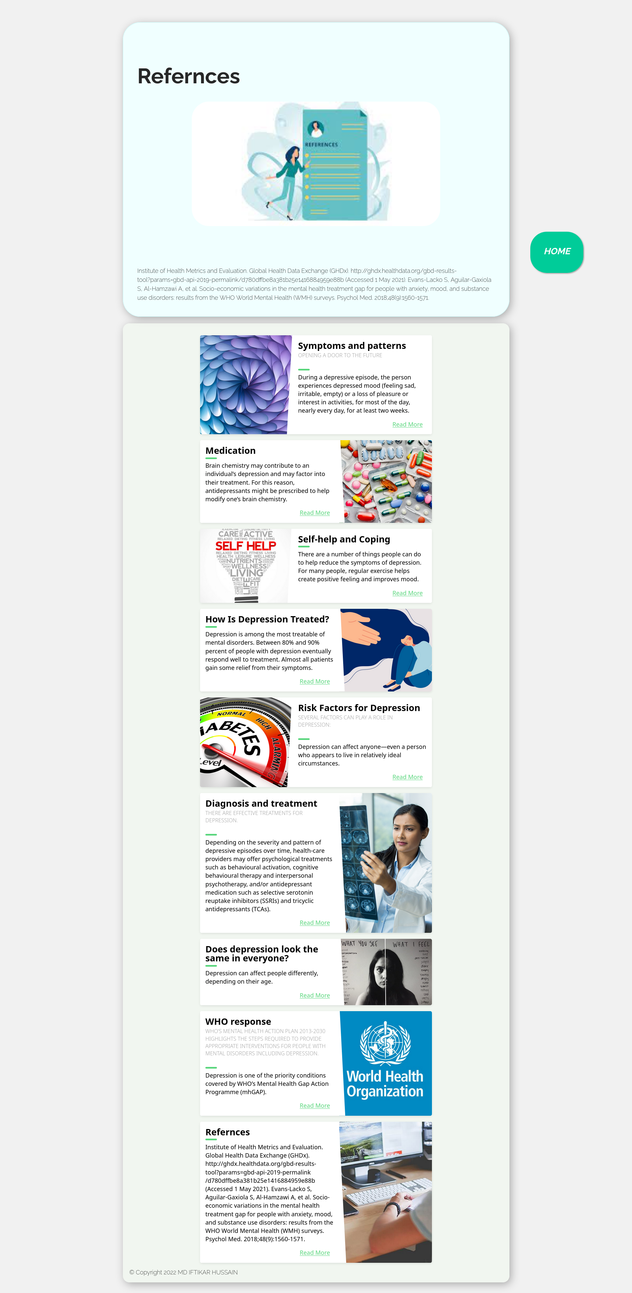

<!DOCTYPE html>

<html lang="en">

<head>

<meta charset="UTF-8">

<meta http-equiv="X-UA-Compatible" content="IE=edge">

<meta name="viewport" content="width=device-width, initial-scale=1.0">

<title>Refernces</title>

<link rel="stylesheet" href="style.css">

</head>

<body>

<div id="title">

<div class="card">

<div class="topic">

<h1>Refernces</h1>

</div>

<img src="assets/refer.jpg" alt="">

<!-- <h2>An Overview</h2> -->

<div class="content">

<br><br><br>

<p> Institute of Health Metrics and Evaluation. Global Health Data Exchange (GHDx).

http://ghdx.healthdata.org/gbd-results-tool?params=gbd-api-2019-permalink/d780dffbe8a381b25e1416884959e88b

(Accessed 1 May 2021).

Evans-Lacko S, Aguilar-Gaxiola S, Al-Hamzawi A, et al. Socio-economic variations in the mental health

treatment gap for people with anxiety, mood, and substance use disorders: results from the WHO World Mental

Health (WMH) surveys. Psychol Med. 2018;48(9):1560-1571.

</p>

</div>

</div>

<div class="banner">

<div class="blog-card">

<div class="meta">

<div class="photo" style="background-image: url(assets/pattern.jpg)"></div>

<ul class="details">

<li class="author"><a href="#">IFTIKAR HUSSAIN</a></li>

<li class="date">Apr. 24, 2022</li>

<li class="tags">

<ul>

<li><a href="#">Learn</a></li>

<li><a href="#">more</a></li>

</ul>

</li>

</ul>

</div>

<div class="description">

<h1>Symptoms and patterns

</h1>

<h2>Opening a door to the future</h2>

<p> During a depressive episode, the person experiences depressed mood (feeling sad, irritable,

empty) or a

loss of pleasure or interest in activities, for most of the day, nearly every day, for at

least two weeks.

</p>

<p class="read-more">

<a href="./symtoms.html">Read More</a>

</p>

</div>

</div>

<div class="blog-card alt">

<div class="meta">

<div class="photo" style="background-image: url(assets/Medication.webp)">

</div>

<ul class="details">

<li class="author"><a href="#">IFTIKAR HUSSAIN</a></li>

<li class="date">July. 15, 2022</li>

<li class="tags">

<ul>

<li><a href="#">Learn</a></li>

<li><a href="#">more</a></li>

<li><a href="#"></a></li>

</ul>

</li>

</ul>

</div>

<div class="description">

<h1>Medication</h1>

<!-- <h2>depression</h2> -->

<p>Brain chemistry may contribute to an individual’s depression and may factor into their

treatment. For this

reason, antidepressants might be prescribed to help modify one’s brain chemistry.

</p>

<p class="read-more">

<a href="./medication.html">Read More</a>

</p>

</div>

</div>

<div class="blog-card">

<div class="meta">

<div class="photo" style="background-image: url(assets/help.jpg)">

</div>

<ul class="details">

<li class="author"><a href="#">IFTIKAR HUSSAIN</a></li>

<li class="date">Apr. 24, 2022</li>

<li class="tags">

<ul>

<li><a href="#">Learn</a></li>

<li><a href="#">more</a></li>

</ul>

</li>

</ul>

</div>

<div class="description">

<h1>Self-help and Coping

</h1>

<!-- <h2>Opening a door to the future</h2> -->

<p> There are a number of things people can do to help reduce the symptoms of depression. For

many people,

regular exercise helps create positive feeling and improves mood.

</p>

<p class="read-more">

<a href="./help.html">Read More</a>

</p>

</div>

</div>

<div class="blog-card alt">

<div class="meta">

<div class="photo" style="background-image: url(assets/treat.jpg)">

</div>

<ul class="details">

<li class="author"><a href="#">IFTIKAR HUSSAIN</a></li>

<li class="date">July. 15, 2022</li>

<li class="tags">

<ul>

<li><a href="#">Learn</a></li>

<li><a href="#">more</a></li>

<li><a href="#"></a></li>

</ul>

</li>

</ul>

</div>

<div class="description">

<h1>How Is Depression Treated?</h1>

<!-- <h2>depression</h2> -->

<p>Depression is among the most treatable of mental disorders. Between 80% and 90% percent of

people with

depression eventually respond well to treatment. Almost all patients gain some relief from

their symptoms.

</p>

<p class="read-more">

<a href="./treated.html">Read More</a>

</p>

</div>

</div>

<div class="blog-card">

<div class="meta">

<div class="photo" style="background-image: url(assets/risk.jpg)"></div>

<ul class="details">

<li class="author"><a href="#">IFTIKAR HUSSAIN</a></li>

<li class="date">Apr. 24, 2022</li>

<li class="tags">

<ul>

<li><a href="#">Learn</a></li>

<li><a href="#">more</a></li>

</ul>

</li>

</ul>

</div>

<div class="description">

<h1>Risk Factors for Depression

</h1>

<h2>Several factors can play a role in depression:</h2>

<!-- <h2>Opening a door to the future</h2> -->

<p> Depression can affect anyone—even a person who appears to live in relatively ideal

circumstances.

</p>

<p class="read-more">

<a href="./risk.html">Read More</a>

</p>

</div>

</div>

<div class="blog-card alt">

<div class="meta">

<div class="photo" style="background-image: url(assets/daignosin.jpg)">

</div>

<ul class="details">

<li class="author"><a href="#">IFTIKAR HUSSAIN</a></li>

<li class="date">July. 15, 2022</li>

<li class="tags">

<ul>

<li><a href="#">Learn</a></li>

<li><a href="#">more</a></li>

<li><a href="#"></a></li>

</ul>

</li>

</ul>

</div>

<div class="description">

<h1>Diagnosis and treatment</h1>

<h2>There are effective treatments for depression. </h2>

<p>Depending on the severity and pattern of depressive episodes over time, health-care providers

may offer

psychological treatments such as behavioural activation, cognitive behavioural therapy and

interpersonal

psychotherapy, and/or antidepressant medication such as selective serotonin reuptake

inhibitors (SSRIs) and

tricyclic antidepressants (TCAs). </p>

<p class="read-more">

<a href="./daignosis.html">Read More</a>

</p>

</div>

</div>

<div class="blog-card alt">

<div class="meta">

<div class="photo" style="background-image: url(assets/look.jpeg)">

</div>

<ul class="details">

<li class="author"><a href="#">IFTIKAR HUSSAIN</a></li>

<li class="date">July. 15, 2022</li>

<li class="tags">

<ul>

<li><a href="#">Learn</a></li>

<li><a href="#">more</a></li>

<li><a href="#"></a></li>

</ul>

</li>

</ul>

</div>

<div class="description">

<h1>Does depression look the same in everyone?</h1>

<!-- <h2>depression</h2> -->

<p>Depression can affect people differently, depending on their age.

</p>

<p class="read-more">

<a href="./look.html ">Read More</a>

</p>

</div>

</div>

<div class="blog-card alt">

<div class="meta">

<div class="photo" style="background-image: url(assets/who.jpg)">

</div>

<ul class="details">

<li class="author"><a href="#">IFTIKAR HUSSAIN</a></li>

<li class="date">July. 15, 2022</li>

<li class="tags">

<ul>

<li><a href="#">Learn</a></li>

<li><a href="#">more</a></li>

<li><a href="#"></a></li>

</ul>

</li>

</ul>

</div>

<div class="description">

<h1>WHO response</h1>

<h2>WHO’s Mental Health Action Plan 2013-2030 highlights the steps required to provide

appropriate

interventions for people with mental disorders including depression. </h2>

<p>Depression is one of the priority conditions covered by WHO’s Mental Health Gap Action

Programme (mhGAP).

</p>

<p class="read-more">

<a href="./who.html">Read More</a>

</p>

</div>

</div>

<div class="blog-card alt">

<div class="meta">

<div class="photo"

style="background-image: url(https://storage.googleapis.com/chydlx/codepen/blog-cards/image-2.jpg)">

</div>

<ul class="details">

<li class="author"><a href="#">Jane Doe</a></li>

<li class="date">July. 15, 2015</li>

<li class="tags">

<ul>

<li><a href="#">Learn</a></li>

<li><a href="#">more</a></li>

<li><a href="#"></a></li>

</ul>

</li>

</ul>

</div>

<div class="description">

<h1>Refernces</h1>

<!-- <h2>WHO’s Mental Health Action Plan 2013-2030 highlights the steps required to provide appropriate

interventions for people with mental disorders including depression. </h2> -->

<p>Institute of Health Metrics and Evaluation. Global Health Data Exchange (GHDx).

http://ghdx.healthdata.org/gbd-results-tool?params=gbd-api-2019-permalink/d780dffbe8a381b25e1416884959e88b

(Accessed 1 May 2021).

Evans-Lacko S, Aguilar-Gaxiola S, Al-Hamzawi A, et al. Socio-economic variations in the

mental health

treatment gap for people with anxiety, mood, and substance use disorders: results from the

WHO World Mental

Health (WMH) surveys. Psychol Med. 2018;48(9):1560-1571.

</p>

<p class="read-more">

<a href="./refer.html">Read More</a>

</p>

</div>

</div>

<footer>&copy Copyright 2022 MD IFTIKAR HUSSAIN </footer>

<a href="index.html" class="float">

<i class="fa fa-plus my-float">

<h2>HOME</h2>

</i>

</a>

</body>

</html>

**CONCLUSION**Depression is one of the most common conditions in primary care, but is often unrecognized, undiagnosed, and untreated. Depression has a high rate of morbidity and mortality when left untreated. Most patients suffering from depression do not complain of feeling depressed, but rather anhedonia or vague unexplained symptoms. All physicians should remain alert to effectively screen for depression in their patients. There are several screening tools for depression that are effective and feasible in primary care settings. An appropriate history, physical, initial basic lab evaluation, and mental status examination can assist the physician in diagnosing the patient with the correct depressive spectrum disorder (including bipolar disorder). Primary care physicians should carefully assess depressed patients for suicide. Depression in the elderly is not part of the normal aging process. Patients who are elderly when they have their first episode of depression have a relatively higher likelihood of developing chronic and recurring depression. The prognosis for recovery is equal in young and old patients, although remission may take longer to achieve in older patients. Elderly patients usually start antidepressants at lower doses than their younger counterparts.

Most primary care physician can successfully treat uncomplicated mild or moderate forms of major depression in their settings with careful psychiatric management (e.g., close monitoring of symptoms, side effects, etc.); maintaining a therapeutic alliance with their patient; pharmacotherapy (acute, continuation, and maintenance phases); and / or referral for psychotherapy. The following situations require referral to psychiatrist: suicide risk, bipolar disorder or a manic episode, psychotic symptoms, severe decrease in level of functioning, recurrent depression and chronic depression, depression that is refractory to treatment, cardiac disease that requires tricyclic antidepressants treatment, need for electroconvulsive therapy (ECT), lack of available support system, and any diagnostic or treatment questions.

Antidepressant medications’ effectiveness is generally comparable across classes and within classes of medications.  The medications differ in side effect profiles, drug-drug interactions, and cost.  The history of a positive response to a particular drug for an individual or a family member, as well as patient preferences, should also be taken into account.  Most psychiatrists agree that an SSRI should be the first line choice.  The dual action reuptake inhibitors venlafaxine and bupropion are generally regarded as second line agents.  Tricyclics and other mixed or dual action inhibitors are third line, and MAOI’s (monoamine oxidase inhibitors) are usually medications of last resort for patients who have not responded to other medications, due to their low tolerability, dietary restrictions, and drug-drug interactions.  Most primary care physicians would prefer that a psychiatrist manage patients requiring MAOI’s.

Psychotherapy may be a first line therapy choice for mild depression particularly when associated with psychosocial stress, interpersonal problems, or with concurrent developmental or personality disorders. Psychotherapy in mild to moderate depression is most effective in the acute phase, and in preventing relapse during continuation phase treatment. Psychotherapy is not appropriate alone for severe depression, psychosis, and bipolar disorders. For more severe depression, psychotherapy may be appropriate in combination with the use of medications. The most effective forms of psychotherapy are those with structured and brief approaches such as cognitive behavioral therapy, interpersonal therapy, and certain problem solving therapies. Regardless of the psychotherapy initiated, “psychiatric management” must be integrated at the same time.

Patients, who live with depression, and their family and friends, have enormous challenges to overcome. Primary care physicians can provide compassionate care, important education, psychiatric monitoring, social support, reassurance, and advocacy for these patients and their loved ones.

**BIBLIOGRAPHY**

**WEBSITES-**

[**https://en.wikipedia.org/**](https://en.wikipedia.org/)

[**https://html.spec.whatwg.org/multipage/index.html**](https://html.spec.whatwg.org/multipage/index.html)

[**http://www.w3schools.com**](http://www.w3schools.com)

<https://codepen.io/>

<https://www.who.int/news-room/fact-sheets/detail/depression>

[https://psychiatry.org/patients-families/depression](https://psychiatry.org/patients-families/depression/what-is-depression)

**BOOKS-**

**1. Design and building websites by Jon Duckett**

**2. The simplified beginner’s guide to html by Clyde Bank Technology**

**3. Learn HTML and CSS fast by Mark Myers**